Degree Project in Technology
Second cycle, 30 credits

Anomaly Detection in District Heating Systems Using Deep Learning on Real-Time Sensor Data
  - Historical analysis and interpretation for future live deployment
Mihailo Cvetkovic

Anomaly Detection in District Heating Systems Using Deep Learning on Real-Time Sensor Data
MIHAILO CVETKOVIC
Master's Programme, ICT Innovation (TIVNM), Cloud and Network Infrastructures, 120.0 credits
Date: June 2026
Supervisor: Mustapha Habib
Examiner: Matthieu Barreau
School of Electrical Engineering and Computer Science
Swedish title: Anomalidetektion i fjärrvärmecentraler med rekonstruktionsbaserade modeller

Abstract
This thesis investigates anomaly detection in district-heating substations using historical operational data. The study adapts a reference encoder-assisted clustering methodology to a smaller case-study setting with longer historical coverage and limited fault labels. The main method is a reconstruction-based autoencoder that models 24-hour patterns of supply temperature, return temperature, and flow rate. The main outcomes are an interpretable anomaly-detection workflow, feature-level anomaly attribution, a comparison between threshold configurations, and a reviewable set of anomaly candidates for later validation on live data.

Sammanfattning
Detta examensarbete undersöker anomalidetektion i ett litet fjärrvärmenät med hjälp av historiska driftsdata från sju kundcentraler. Arbetet utgår från HEAT-artikeln som metodologisk referens, men anpassar angreppssättet till en situation med färre undercentraler, längre historisk täckning och begränsad tillgång till felmärkta data. Huvudmetoden är en rekonstruktionsbaserad anomalidetektor byggd på 24-timmarsfönster av framledningstemperatur, returtemperatur och flöde. I resultatpaketet med sju byggnader analyserade modellen mellan 323 och 1113 behållna fönster per byggnad. Med den slutliga 3-sigma-tröskeln varierade andelen flaggade anomalier från 0,21 procent för Abat Oliba till 4,65 procent för Hostatgeria DHW Radiators. Det tydligaste enskilda fallet var Hostatgeria Underfloor, där 5 av 323 fönster flaggades och den starkaste anomalin också överlappade den ingenjörsmässiga låg-delta-T-baslinjen. Analysen av dominerande variabel visade att anomalibeteendet inte var enhetligt: vissa byggnader var främst flödesdominerade, andra främst returdominerade, medan Underfloor och Nostra Senyora gav de tydligaste framledningsdominerade fallen. Resultaten visar att rekonstruktionsbaserad anomalidetektion kan ge tolkbara anomalikandidater i en realistisk fjärrvärmesituation med svaga etiketter, men också att slutlig validering fortfarande kräver domängranskning och framtida utvärdering på live-data.

Keywords
district heating; anomaly detection; autoencoder; reconstruction error; time-series analysis
fjärrvärme; anomalidetektion; autoencoder; rekonstruktionsfel; tidsserieanalys

Acknowledgments
Acknowledgments to be completed.

List of Acronyms and Abbreviations
AE - Autoencoder
DH - District Heating
DHW - Domestic Hot Water
Reference method - Hierarchical encoder-assisted clustering for substation fault detection
MSE - Mean Squared Error
Ts - Supply temperature
Tr - Return temperature
Table of Contents
Anomaly Detection in District Heating Systems Using Deep Learning on Real-Time Sensor Data 1
Historical analysis and interpretation for future live deployment 1
Abstract 3
Sammanfattning 4
Keywords 4
Acknowledgments 4
List of Acronyms and Abbreviations 4
1 Introduction 7
1.1 Problem setting 7
1.2 Ethics and sustainability 7
1.3 Quantitative and qualitative analysis 8
1.4 Thesis aim and research questions 8
2 Background 10
2.1 District-heating anomaly detection 10
2.2 Reference encoder-assisted clustering method 11
2.3 Supervised and unsupervised fault detection 11
2.4 Reconstruction-based anomaly detection 12
2.5 Physics-informed feature construction 12
2.6 Related work positioning 13
3 Method 14
3.1 Overview 14
3.1.1 Implementation pipeline 17
3.2 Autoencoder architecture 18
3.3 Feature construction 20
3.4 Thresholding 20
3.5 Engineering baseline 23
3.6 Clustering roles 23
3.7 Evaluation strategy in a weak-label setting 24
4 Results 25
4.1 Current main result set 26
4.2 Dominant-feature interpretation 38
4.3 Low delta-T overlap 40
4.4 Operating regimes 41
4.5 Threshold comparison 43
4.6 Train-test split and anomaly timing 45
5 Discussion 46
5.1 What is currently convincing 46
5.2 What remains uncertain 46
5.3 Implications for live deployment 47
5.4 Threats to validity 48
6 Conclusion 48
6.1 Future work 49
References 50

1 Introduction
Operational anomalies are a persistent issue in modern district-heating networks because substations operate continuously and their behaviour changes with demand, control settings, season, and data quality. At the same time, modern substations produce large amounts of operational time-series data that can be used for monitoring. This creates a clear methodological need: to take advantage of available substation data to detect unusual or inefficient operation even when confirmed fault labels are sparse, incomplete, or unavailable. In this setting, anomaly detection is a pragmatic alternative because it identifies data points and periods that deviate from historically learned behaviour without requiring a fully labelled fault dataset [2, 3].

1.1 Problem setting
District-heating systems distribute thermal energy from centralized production to connected buildings through a shared network of pipes, heat exchangers, and local substations. At substation level, supply temperature, return temperature, flow rate, and power together describe how heat is transferred from the network side to the building side. This makes monitoring inherently multivariate: inefficient or abnormal operation may appear through elevated return temperature, weak temperature difference, unstable flow, or a combination of these effects.

1.2 Ethics and sustainability
The sustainability motivation of this thesis is direct. District-heating systems are most effective when connected substations extract heat efficiently and return cooler water to the network. Poor control, hidden faults, or persistently inefficient operating periods can increase return temperature, reduce overall network efficiency, and make heat distribution less effective for the rest of the connected system [19, 20]. Better monitoring therefore has a practical sustainability role: it can help prioritize the building periods where wasted energy, poor control behaviour, or maintenance-relevant inefficiency are most likely to occur.
There is also an ethics dimension. Automated anomaly detection should support engineering review rather than replace it. In this thesis, anomaly flags are not treated as proof of fault. They are treated as review signals that help direct limited expert attention toward unusual operating windows. This is important because a weak-label industrial dataset can contain missing values, sensor artifacts, and building-specific operating patterns that a purely automatic system may misread if its outputs are interpreted without domain context [7, 11]. The ethical goal is therefore not blind automation, but responsible decision support: more transparent monitoring, better prioritization, and more accountable interpretation of abnormal behaviour.

1.3 Quantitative and qualitative analysis
The thesis combines quantitative and qualitative analysis. The quantitative part includes window counts, reconstruction errors, anomaly rates, threshold comparisons, dominant-feature summaries, and baseline-overlap statistics. These are needed to understand how the detector behaves across buildings and under different thresholding choices. The qualitative part consists of inspecting the highest-scoring anomaly windows, comparing supply, return, flow, and delta-T behaviour, and discussing those windows in engineering terms together with the supervisor. This combination is necessary because the available dataset does not support fully labelled benchmark evaluation. Quantitative results show where the detector reacts; qualitative review is needed to judge whether those reactions are meaningful.

1.4 Thesis aim and research questions
The thesis therefore aims to build and evaluate an anomaly-detection pipeline that can identify physically interpretable abnormal operating periods from historical district-heating data and later be transferred to live data as it becomes available. The work is motivated by a reference encoder-assisted clustering methodology for district-heating fault detection [1]. However, the available KTH thesis dataset differs from that reference setting in two important ways. First, the network is much smaller, which reduces the statistical strength of pure peer-group comparison. Second, the historical coverage is longer, which makes per-substation temporal modelling more attractive than relying only on network-wide clustering. For this reason, the thesis treats reconstruction-based anomaly detection as the primary method and uses clustering mainly as a secondary interpretation layer.
More concretely, the thesis is interested in whether a model trained on historical windows can flag operating periods that are both statistically unusual and physically interpretable. This distinction matters. A detector that produces many high scores is not automatically useful if those scores cannot be discussed in terms of supply temperature, return temperature, flow behaviour, or known engineering concerns. The emphasis throughout the thesis is therefore on interpretable anomaly candidates rather than anomaly counts alone.
A clear research gap follows from this comparison. Much of the strongest recent work either assumes a larger peer population for comparison, access to cleaner labelled maintenance events, or an evaluation setup built around benchmark-style metrics [1, 5, 7, 8]. The present thesis works in a different regime: a smaller set of consumer substations, long historical time-series coverage, and limited fault confirmation. The contribution is therefore not to outperform a labelled benchmark, but to show that a reconstruction-based workflow can still produce structured, feature-level anomaly evidence that is technically defensible and operationally reviewable in this weaker-data setting.
The main research question is:
Can a reconstruction-based anomaly-detection methodology identify interpretable abnormal operating periods in district-heating substations when complete fault labels are unavailable?
The thesis also addresses the following supporting questions:

What is the impact of changing the configuration settings of the proposed methodology on the expected anomaly-detection results?
Can clustering support interpretation in a small district-heating case study where the number of studied substations is limited?
The main contributions of the thesis are threefold. First, it adapts a reconstruction-based anomaly detector to a small district-heating setting with limited labels using autoencoders. Second, it introduces a feature-level interpretation view that attributes anomalies to supply temperature, return temperature, or the flow-rate channel. Third, it compares the learned detector with simple engineering baselines and clustering-based interpretation views in order to understand which anomalies appear physically meaningful. The rest of the thesis is organized as follows. Chapter 2 reviews the relevant background and the reference encoder-assisted clustering methodology. Chapter 3 presents the anomaly-detection methodology. Chapter 4 summarizes the experimental results. Chapter 5 discusses interpretation, limitations, and implications for live deployment. Chapter 6 concludes the thesis and outlines future work.

2 Background

2.1 District-heating anomaly detection
District-heating systems transport thermal energy from a central production source to buildings through a pipe network and local substations [19]. At the substation level, measurements such as supply temperature, return temperature, flow, and power provide indirect evidence about how effectively heat is being transferred to the building side. When the system behaves abnormally, that abnormality may appear as an unusual temperature profile, poor separation between supply and return, unstable flow behaviour, or some combination of these effects. In practical monitoring, low supply-return temperature difference, or low delta-T, is often used as an initial engineering warning sign because it can indicate poor heat extraction, inefficient operation, or high return-temperature behaviour [5, 6]. However, low delta-T only captures one narrow anomaly family and cannot explain all relevant abnormal operating patterns. This is one reason recent district-heating research has increasingly combined physical intuition with data-driven modelling. Simple rules remain useful as references, but they are too narrow to represent the full range of possible substation faults or inefficient operating regimes [21].
Broader time-series anomaly-detection research reaches a similar conclusion. Recent reviews emphasize that unsupervised methods remain especially important when anomaly labels are scarce, expensive, or operationally ambiguous, but they also note that method comparison becomes harder because results depend strongly on the dataset, anomaly type, and evaluation protocol [2, 8]. This is directly relevant for district-heating data, where many suspicious periods can be recognized by operators as unusual without being linked to a single confirmed fault label.
District-heating-specific studies also span several different problem formulations. Calikus et al. study data-driven heat-load patterns and show that operational behaviour can be meaningfully grouped even before explicit fault labels are introduced [6]. SHEDAD moves further toward anomaly detection by building neighborhood-aware comparisons between substations and isolating anomalous supply-temperature and performance behaviour in larger urban networks [5]. More recently, Roelofs et al. highlight the value of labelled service data and event-based evaluation for predictive maintenance, which is especially relevant for understanding what this thesis can and cannot validate with its current historical dataset [7].

2.2 Reference encoder-assisted clustering method
The reference method proposes a hierarchical, encoder-assisted clustering approach for fault detection in district-heating substations [1]. Its central idea is to transform time-series observations into a compact representation and then use clustering to construct local peer groups that can be compared against one another. This is a sensible design in a large network with many similar substations, because the method can exploit similarities and differences between multiple operating units instead of relying only on the history of a single site. In that framing, the encoder is not only a compression device. It is also a way to produce a representation on which clustering becomes more meaningful than on raw high-dimensional measurements.
In this thesis, the reference method remains a methodological starting point rather than a blueprint copied without modification. The available dataset contains far fewer usable consumer sheets than the reference case study, and this changes what clustering can realistically achieve. With a small number of buildings, clustering alone is less reliable as a primary fault-detection mechanism because the peer structure is weak. The practical consequence is that clustering is still useful, but its role shifts toward interpretation: it helps describe operating regimes and groups of anomalies after detection, rather than serving as the main detector by itself.

2.3 Supervised and unsupervised fault detection
A useful distinction for this thesis is the difference between supervised and unsupervised fault detection. In a supervised setting, the training data contain reliable labels that state which observations correspond to known fault classes and which correspond to normal operation. A supervised model therefore learns a direct mapping from measured signals to predefined labels. This is attractive when labels are abundant and trustworthy, because the resulting performance can be evaluated with standard metrics such as accuracy, precision, recall, and F1-score. In anomaly-detection practice, however, such clean labels are often unavailable, incomplete, or expensive to obtain. Classical anomaly and novelty-detection surveys make clear why unsupervised formulations therefore remain practically important [10, 12]. Older outlier-detection work provides the statistical background for that same problem setting [22].
The present project does not have that kind of labelled dataset. Most windows in the historical data are unlabeled, and even suspicious periods are usually not tied to a confirmed fault record. For that reason, the problem is better framed as unsupervised anomaly detection. In an unsupervised setting, the model is trained to capture the structure of historical normal-looking behaviour without being told explicit fault classes. A high anomaly score does not mean that a specific known fault has been diagnosed. It means that the operating pattern is sufficiently different from the learned historical structure that it deserves review. This distinction matters for the whole thesis: the contribution is not a supervised classifier of named faults, but a ranking and interpretation workflow for unusual operating windows. The evaluation consequence is equally important. Without stable labels, one must rely more heavily on score distributions, qualitative inspection, expert review, and careful discussion of what an anomaly flag actually means, which is fully consistent with the cautions raised in unsupervised outlier-evaluation research [11, 23].

2.4 Reconstruction-based anomaly detection
An autoencoder is a neural network trained to reproduce its own input at the output layer [4]. In the thesis pipeline, each input is a 24-hour multivariate window containing three synchronized channels: supply temperature, return temperature, and a flow-related channel. The encoder compresses the window into a latent representation that retains the most important structure, and the decoder uses that representation to reconstruct the original signal sequence. If a window follows patterns that are common in the historical training data, the model usually reconstructs it well and the reconstruction error remains low. If a window contains an unusual temporal pattern, one or more channels are reconstructed less accurately and the reconstruction error increases. This makes the reconstruction error a natural anomaly score in situations where explicit fault labels are not available. In this thesis, anomaly detection is joint at the window level because all three channels are reconstructed together, but interpretation is feature-specific afterward because the reconstruction error is also decomposed by channel. That decomposition is what allows a flagged window to be discussed as mainly supply-related, return-related, or flow-related rather than only 'anomalous' in a generic sense.
Explainability is also an active topic in the autoencoder literature. Recent work on robust and explainable unsupervised autoencoders argues that reconstruction-based detectors become more useful when the anomaly score can be decomposed into understandable temporal or feature-level contributions rather than being treated as a single opaque number [9]. That argument aligns closely with the design choice in this thesis to inspect per-feature reconstruction errors and dominant-feature labels after each window is flagged.

2.5 Physics-informed feature construction
The third input channel is motivated by the thermal balance relationship between power, temperature difference, and flow. In simplified form, the relation can be written as:
Q = m_dot c_p (T_s - T_r) (1)
where Q is thermal power, m_dot is the measured mass flow rate, c_p is the specific heat capacity of water, T_s is supply temperature, and T_r is return temperature. This relationship links the thermal and hydraulic sides of substation operation and explains why the flow-rate channel is useful for anomaly detection. Unusual heat-transfer behaviour may not be fully visible from temperature signals alone, so the model uses temperature and flow-rate measurements jointly.
Taken together, these background points motivate the methodological structure used later in the thesis: temperatures and flow are modeled jointly, autoencoder reconstruction provides the main anomaly score, engineering rules are retained as a reference baseline, and clustering is used to help interpret the detected behaviour rather than replace the detector itself.

2.6 Related work positioning
The thesis sits at the intersection of three research lines. The first is classical anomaly and novelty detection, where the main question is how to identify rare or abnormal observations without assuming that all possible fault classes are known in advance [10, 12]. Older outlier-detection work provides the statistical framing behind that problem class [22]. The second is unsupervised time-series anomaly detection, where reconstruction models are used to learn normal temporal structure and assign anomaly scores from reconstruction failure [8, 9]. Later autoencoder-based and sequence-based studies show how this idea is implemented in practice [14, 15, 16, 17]. The third is district-heating-specific monitoring, where physical interpretation, efficiency loss, and operational validation matter as much as statistical detection performance. In this thesis, that line of work is represented by HEAT [1], by data-driven grouping of operational behavior [6], by neighborhood-based anomaly detection [5], and by more recent service-validated evaluation work [7].
Compared with the broader anomaly-detection literature, the present thesis is deliberately conservative in model ambition. It does not attempt to claim a novel neural architecture or a state-of-the-art benchmark result. Instead, it focuses on a technically defensible end-to-end workflow for a real weak-label setting: daily window construction, reconstruction-based scoring, feature-level attribution, engineering comparison, and cross-building review. That positioning is appropriate because the central challenge in the available data is not model expressiveness alone, but how to convert imperfect historical measurements into anomaly evidence that remains understandable and reviewable.
Compared with the reference encoder-assisted clustering method, the main methodological difference is scale. HEAT is strongest when a larger population of substations supports peer-based comparison and clustering. In the present project, the smaller number of usable buildings makes pure peer comparison less reliable as a primary detector. For that reason, the thesis gives reconstruction against each building's own historical behavior the central role, while still retaining clustering as a secondary interpretation layer. This keeps the work aligned with the spirit of HEAT while adapting it to the actual statistical structure of the available data.

3 Method

3.1 Overview
The dataset and preprocessing choices are treated as part of the method because they define the input windows supplied to the detector. The historical data, retained variables, missing-data handling, and result-set scope are therefore summarized here before the modelling pipeline.
The thesis uses historical data from a district-heating network associated with Montserrat / Abat Oliba. During the broader exploratory phase, seven heating-consumer sheets were reviewed in order to understand data quality, coverage, and modelling feasibility. The source data are split across two Excel workbooks. Abat Oliba and Hostatgeria Underfloor are read from District Heating_updated_16_07_2025_2.xlsx, while Abat Cisneros, Abat Garriga, and Abat Marcet are read from District Heating_updated_16_07_2025_1.xlsx. All seven reviewed heating-consumer sheets are retained in the main thesis result set:
- cons_abat_cisneros
- cons_abat_garriga
- cons_abat_marcet
- cons_abat_oliba
- cons_hostatgeria_underfloor_hea
- cons_hostatgeria_DHW_radiators
- cons_nostra_senyora
Hostatgeria DHW Radiators and Nostra Senyora are also retained in the main thesis result set. They are interpreted mainly through summary statistics, anomaly inspections, and cross-building comparisons rather than through the reconstruction-error timeline figure.
These sheets are complemented by reports, drawings, and contextual material about the network. That supporting context is important because it provides an engineering frame for interpretation even when explicit fault labels are unavailable. In other words, the results are not evaluated only as abstract machine-learning scores; they are also discussed in relation to how the substations are expected to behave physically.
These seven sheets should not be understood as seven identical substations observed under identical conditions. They differ in coverage, missing-data behaviour, apparent heating intensity, and the frequency of clearly inactive periods. Some sheets contain long stretches that are visually flat or weakly informative for reconstruction-based modeling, while others show richer day-to-day variation. This heterogeneity is part of the practical challenge of the thesis and helps explain why a single shared detector can still produce building-specific anomaly behaviour.
The most consistently available variables across the modeled heating-consumer sheets are the directly recorded operational measurements listed below. These measured variables form the basis for both the model inputs and the later engineering checks:
- timestamp
- supply temperature
- return temperature
- power
From these raw measurements, additional features are constructed, most notably delta-T and the final flow-related model channel. These derived quantities are useful because they translate the raw sensor readings into quantities that are more directly linked to heat-transfer behaviour and anomaly interpretation.
The preprocessing pipeline is designed to retain daily windows that reflect meaningful heating behaviour while discarding windows that are too incomplete or too inactive to support reliable interpretation. The main decisions are:
- active-heating rows are selected using positive power and positive delta-T
- data is resampled to 15-minute intervals
- windows are formed as 24-hour segments with 12-hour stride
- windows with low data completeness or insufficient active-heating share are discarded
- channels are normalized before being passed to the autoencoder
Taken together, these decisions reduce the influence of missing data, long inactive periods, and weakly informative windows. More precisely, each sheet is timestamp-sorted, delta-T is computed as supply minus return, non-active periods are masked using positive power and positive delta-T, the signals are resampled to 15-minute medians, and only short gaps are interpolated. A 24-hour window therefore contains 96 synchronized time steps per channel, and the 12-hour stride creates overlap so that abrupt changes are less likely to fall exactly on window boundaries. Windows are kept only when at least 60 percent of their resampled points correspond to active heating and at least 85 percent of the three-channel samples are complete. The goal is not simply to maximize the number of windows, but to preserve windows that are comparable enough for reconstruction-based modelling and later interpretation.
The unequal retained-window counts are therefore a data-quality result as well as a preprocessing result. A building contributes fewer windows not only when its original time span is shorter, but also when more of its resampled periods fail the active-heating requirement, contain long missing gaps, or are dominated by values that do not support meaningful daily reconstruction. For this reason, the retained-window count should not be read as a neutral sample-size statistic alone; it also summarizes how much of each sheet remains usable after applying the thesis quality criteria.
The most important limitations of the dataset are listed below. They affect both model evaluation and the strength of any engineering conclusions that can be drawn directly from the data:
- lack of reliable fault labels
- heterogeneity across substations
- possible instability in derived flow when delta-T is small
- variation in data quality, including zeros and missing periods
Because of these limitations, evaluation in this thesis is based on anomaly review, cross-method comparison, and supervisor or domain interpretation rather than standard supervised metrics such as accuracy, recall, or F1-score. This is an important methodological point: the thesis is primarily about finding interpretable anomaly candidates in a realistic low-label setting, not about optimizing a conventional labelled benchmark. That makes the work closer in spirit to recent unsupervised district-heating studies and further motivates the need for richer visual inspection and later live-data validation [5, 7].
The thesis result set now includes all seven modeled heating-consumer sheets:
- Abat Cisneros
- Abat Garriga
- Abat Marcet
- Abat Oliba
- Hostatgeria DHW Radiators
- Hostatgeria Underfloor
- Nostra Senyora
For most result figures, all seven buildings are kept in order to preserve the full comparative picture. The only exception is the reconstruction-error timeline comparison, where Abat Oliba and Hostatgeria Underfloor are omitted because long faulty constant-value stretches make that specific plot harder to interpret. They are still retained everywhere else in the thesis result set.
The final workflow used in the thesis can be summarized as the sequence below. The structure is intentionally simple: first prepare comparable windows, then model historical normal behaviour, then score and interpret anomalous windows:
- preprocess each heating-consumer sheet into retained 24-hour windows
- construct three model channels: supply temperature, return temperature, and the flow channel
- train a 1D convolutional autoencoder on the historical windows
- compute reconstruction error for each window
- flag anomalous windows using a training-distribution threshold
- attribute each anomaly to its dominant feature using per-feature reconstruction error
- compare the detected anomalies with engineering baselines and clustering-based interpretation views

3.1.1 Implementation pipeline
The thesis workflow is implemented through a small set of scripts that correspond directly to the methodological stages of the pipeline. The purpose of this subsection is not to document every line of code, but to state clearly which computational step produces each intermediate result used later in the thesis.
prepare_autoencoder_windows.py prepares one building sheet for modeling. It loads the selected workbook and sheet, computes delta-T, constructs the three model channels, filters to active-heating periods, resamples the data to 15-minute intervals, forms overlapping 24-hour windows with 12-hour stride, applies completeness and activity thresholds, and stores the retained windows together with feature statistics used for normalization.
train_autoencoder.py loads the prepared windows, applies the chronological train-test split, fits the convolutional autoencoder on the training portion, and saves the trained model parameters together with the normalization terms needed for later reconstruction.
inspect_autoencoder_windows.py applies the trained model to all retained windows, computes total and per-feature reconstruction errors, applies the anomaly threshold, and writes the summary tables and inspection figures that support the result interpretation.
The comparison and visualization scripts then summarize the model outputs at building level. These scripts aggregate anomaly counts, dominant-feature assignments, baseline overlap, threshold comparisons, and clustering summaries into the figures used throughout Chapters 4 and 5. In this sense, the scripts are not separate from the method; they are the executable form of the methodological pipeline described in this thesis.

3.2 Autoencoder architecture
The current architecture is a compact 1D convolutional autoencoder. Each 24-hour input window is represented as a three-channel sequence of length 96. The encoder first applies a one-dimensional convolution with 16 output channels, kernel size 5, and padding 2, followed by a ReLU activation and max pooling by a factor of 2. A second convolution maps the signal to 16 latent channels with the same kernel size and padding, again followed by ReLU and max pooling. After the two pooling operations, the temporal resolution has been reduced from 96 to 24 time steps, so the latent representation is a compressed multichannel summary of the daily pattern. The decoder then uses two transposed convolutions with stride 2 to upsample the latent signal back to the original sequence length and reconstruct the three input channels. This architecture was chosen as a conservative baseline. The basic autoencoder idea follows Hinton and Salakhutdinov [4]. Autoencoder-based anomaly detection has since been used by Sakurada and Yairi [15] and extended to richer multivariate settings by Zong et al. [16]. Sequence reconstruction for multivariate anomaly detection is also a standard design choice in Malhotra et al. [14]. A broader review of such detectors is given by Belay et al. [17].
The mathematical formulation of the autoencoder is defined per building. Let X = {x_i}_{i=1}^N denote the retained training windows for one building after preprocessing and normalization. Each input window contains C = 3 channels and T = 96 time steps:
x_i in R^{C x T}, C = 3, T = 96. (2)
The encoder maps the input window to a lower-dimensional latent representation:
z_i = f_theta(x_i). (3)
The decoder maps this latent representation back to the original input space:
x_hat_i = g_phi(z_i) = g_phi(f_theta(x_i)). (4)
The model parameters theta and phi are fitted by minimizing mean squared reconstruction loss over the training windows:
theta*, phi* = argmin_{theta,phi} (1/N) sum_{i=1}^N (1/(C T)) sum_{c=1}^C sum_{t=1}^T (x_{i,c,t} - x_hat_{i,c,t})^2. (5)
After training, the total reconstruction error for a retained window is used as the anomaly score:
e_i = (1/(C T)) sum_{c=1}^C sum_{t=1}^T (x_{i,c,t} - x_hat_{i,c,t})^2. (6)
To make the anomaly interpretable, the same reconstruction error is decomposed per feature channel:
e_{i,c} = (1/T) sum_{t=1}^T (x_{i,c,t} - x_hat_{i,c,t})^2. (7)
The dominant anomaly feature is then defined as the channel with the largest feature-level reconstruction error:
d_i = argmax_c e_{i,c}. (8)
This formulation clarifies the role of the autoencoder in the thesis. It is not trained to classify known faults. It is trained to reconstruct recurring daily operating patterns. A high value of e_i indicates that the model could not reconstruct the window using the normal structure learned from historical data, while d_i identifies whether the reconstruction failure is mainly supply-temperature, return-temperature, or flow-rate related.
Figure 1 gives a compact schematic of the reconstruction-based detector used throughout the thesis.
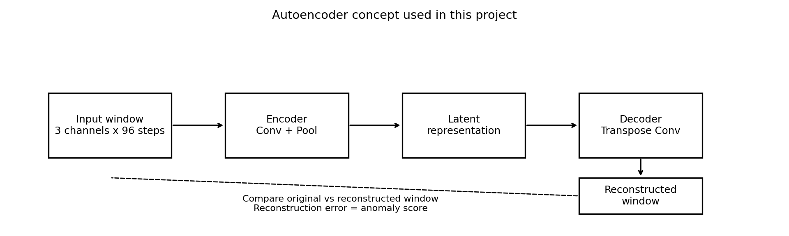
Figure 1. Conceptual view of the reconstruction-based anomaly detector. A 24-hour window containing supply temperature, return temperature, and the flow channel is encoded, reconstructed, and scored by reconstruction error.
Source: author-generated schematic of the thesis pipeline.
Interpretation. The encoder compresses each 24-hour multivariate window into a compact internal representation and the decoder reconstructs it. Windows that follow the learned normal operating patterns reconstruct with low error, while unusual joint behaviour across temperature and flow reconstructs poorly and receives a higher anomaly score.
Figure 1A shows an example training-history plot for the Hostatgeria Underfloor autoencoder.
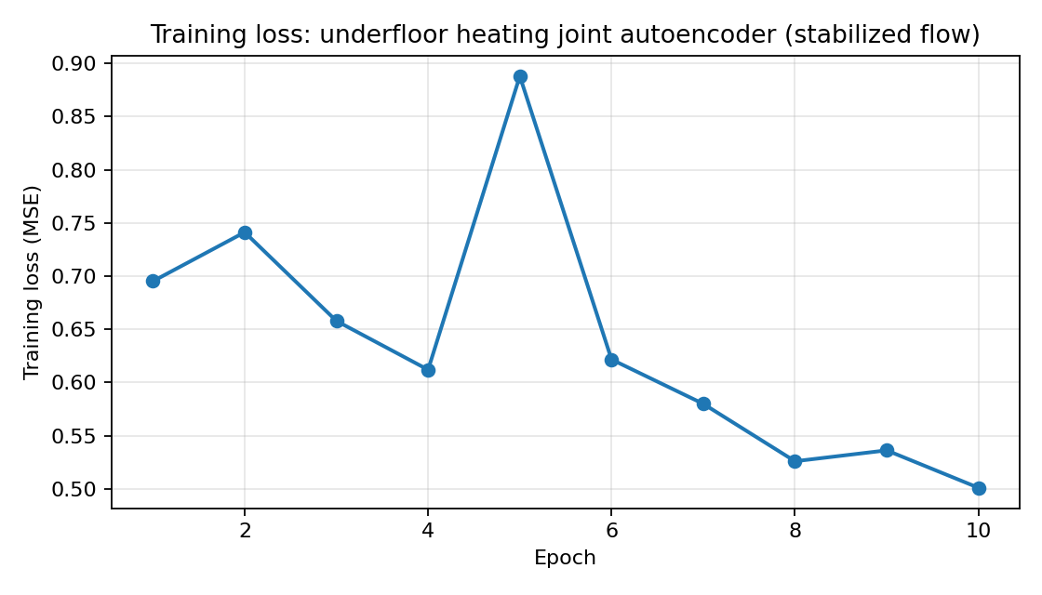
Figure 1A. Training history for the Hostatgeria Underfloor autoencoder.
Source: author-generated figure from the autoencoder training run.
Interpretation. The training-history plot is used as a model-quality check. A decreasing and stabilizing training loss indicates that the autoencoder learned to reconstruct the retained windows rather than failing to train. This does not prove that every flagged window is a physical fault, but it supports the basic reconstruction premise used by the anomaly detector.

3.3 Feature construction
The model uses three synchronized channels per 24-hour window:
- supply temperature
- return temperature
- flow channel
The flow-rate channel is included because thermal anomalies are often easier to interpret when temperature behaviour is viewed together with hydraulic behaviour. In the final thesis framing, flow rate is treated as a measured sensor channel. The method therefore uses the three synchronized input signals directly: supply temperature, return temperature, and flow rate. This keeps the contribution of the thesis focused on anomaly detection and interpretation, rather than on reconstructing intermediate sensor quantities.
The feature construction stage is where the thesis connects physical reasoning with statistical modeling. Supply and return temperatures provide the direct thermal state of the substation, while the flow channel adds hydraulic context that helps distinguish between similar temperature patterns with different underlying operating behaviour. This is important because an unusual return-temperature pattern may have a different interpretation when it occurs together with steady flow than when it occurs together with abrupt flow changes.
In practice, the final three-channel representation is therefore a compromise between engineering meaning and model stability. The channels must remain interpretable enough for later anomaly review, but also regular enough that the autoencoder learns recurring daily structure rather than overfitting rare spikes or missing-data artifacts. That balance is one reason the thesis emphasizes channel-level interpretation after detection, instead of treating the latent representation as self-explanatory.

3.4 Thresholding
Two threshold rules were evaluated:
- training 99th percentile (p99)
- training mean plus three standard deviations (3-sigma)
The latest main result pack uses the 3-sigma rule, following supervisor guidance. Concretely, the windows are ordered chronologically and the first 80 percent are used for model fitting. After training, the model reconstructs all retained windows, the total reconstruction error is computed as the mean squared difference across all channels and time steps, and the anomaly threshold is estimated only from the training subset. Under the 3-sigma rule, a window is flagged when its total reconstruction error exceeds the training mean plus three training standard deviations. The same logic is also applied channel-wise so that supply, return, and flow-specific reconstruction errors can be compared afterward. Neither threshold is uniformly stricter across all sheets. That depends on the shape of the training reconstruction-error distribution, which is consistent with the evaluation concerns discussed by Campos et al. [11] and by Zimek and Filzmoser [23]. Belay et al. also note that score behavior and thresholding are central practical issues in multivariate time-series anomaly detection [17].
A second important design choice is that the windows are split chronologically rather than randomly. This means the model is fitted on the earlier portion of the retained history and then evaluated on later periods. The purpose is not only statistical hygiene. It also reflects the intended operational use case, where a detector trained on historical data will later be applied to new incoming windows. A random split would mix early and late behaviour and make the evaluation less representative of prospective monitoring. This choice is also consistent with the broader concern in anomaly-detection evaluation that unrealistic sampling protocols can overstate performance or obscure deployment-relevant behavior [11, 23].
In mathematical terms, the 3-sigma threshold used in the final result pack is written as tau = mu_train + 3 sigma_train, where mu_train is the mean reconstruction error on the training windows and sigma_train is the corresponding training standard deviation. A retained window i is flagged when its total reconstruction error e_i is greater than tau:
tau = mu_train + 3 sigma_train. (9)
a_i = 1[e_i > tau]. (10)
The 3-sigma rule is easy to explain and is commonly associated with outlier screening under approximately concentrated error distributions. It is not identical to the p99 threshold: p99 fixes the expected upper-tail fraction in the training set, while 3-sigma depends on both the mean and spread of the training errors. As a result, either rule can be stricter depending on whether the training-error distribution is compact, skewed, or contains a heavy tail.
An interquartile-range threshold was also considered conceptually because it is a standard alternative when the error distribution is not close to normal. In that case, an upper threshold can be written as Q3 + k IQR, where IQR = Q3 - Q1. This thesis keeps the 3-sigma rule as the main reported threshold because it matches the supervisor's guidance and gives a transparent comparison across sheets, but the non-normal shape of some reconstruction-error distributions remains a limitation when interpreting alert volume.
Figure 2 shows the training reconstruction-error distributions used to compare the p99 and 3-sigma threshold rules.
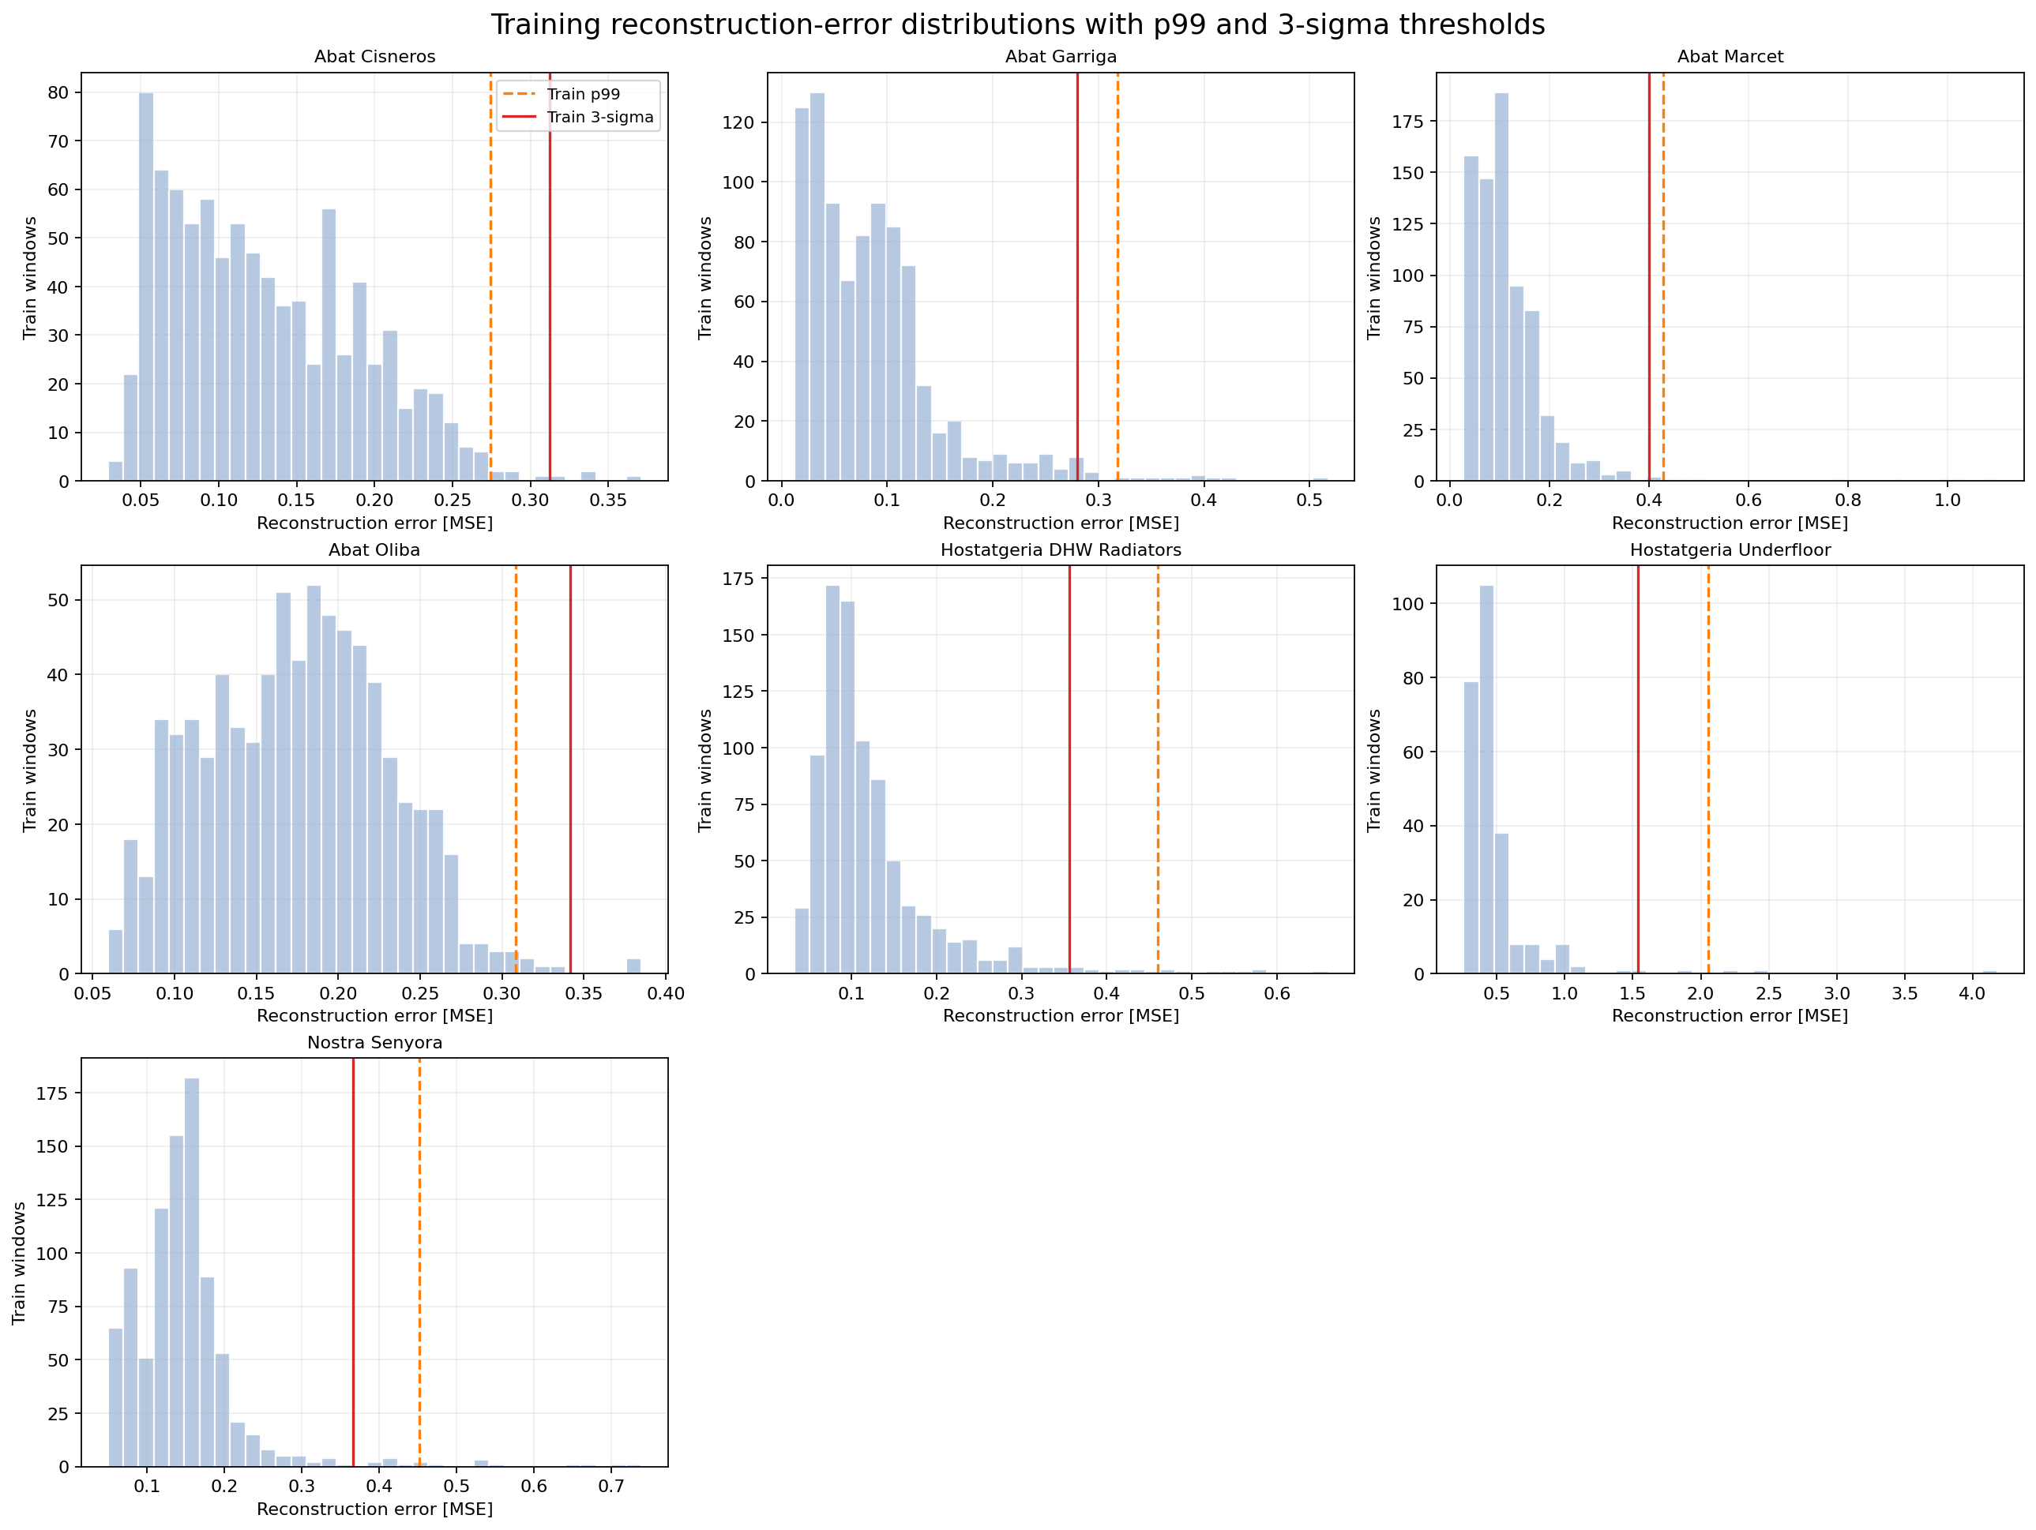
Figure 2. Training reconstruction-error distributions for the modeled sheets, shown with both the p99 threshold and the 3-sigma threshold.
Source: author-generated figure based on historical training-window reconstruction errors.
Interpretation. This figure shows that the threshold choice depends on the shape of each building's training-error distribution. Where the right tail is long, the p99 and 3-sigma cutoffs can separate noticeably, which explains why the number of flagged windows changes from sheet to sheet when the threshold rule is changed.
The thresholding stage should be understood as a calibration step rather than a separate detector. The autoencoder first produces a continuous reconstruction-error score for every retained window. The threshold then converts that score into a review decision. This distinction matters because the scientific question is not only whether the model can rank unusual windows, but also whether the chosen cutoff produces a manageable and interpretable alert set under realistic low-label conditions [11, 12, 23].
The comparison between p99 and 3-sigma is useful for precisely this reason. The p99 rule is distribution-free in the sense that it depends only on the empirical upper tail of the training errors, while the 3-sigma rule depends on the training mean and spread. If the error distribution is compact and roughly symmetric, the rules may behave similarly. If the error distribution is skewed or has a heavy right tail, the resulting anomaly counts can diverge substantially. The thesis therefore treats threshold choice as part of the method design, not as a cosmetic post-processing detail [11, 23].

3.5 Engineering baseline
The engineering baseline is a low delta-T anomaly rule computed only on active-heating rows. It is not used by the autoencoder. Instead, it is used afterward to check whether detected anomaly windows overlap a simple, physically interpretable warning signal. The implementation uses the active-heating delta-T distribution for each sheet, computes a robust modified z-score, and marks strongly negative deviations as low delta-T events. A reviewed anomaly window is then said to overlap the baseline if at least one low delta-T event occurs inside that same 24-hour window.
The baseline has two roles in the thesis. First, it provides a familiar engineering reference that helps test whether at least some autoencoder anomalies correspond to a plausible and well-understood inefficiency signal. Second, it helps show what the learned detector contributes beyond a simple rule. When the autoencoder flags windows that do not overlap the low delta-T baseline, the interpretation challenge becomes whether those windows still display coherent abnormal thermal or hydraulic behaviour rather than just numerical noise.

3.6 Clustering roles
Two clustering roles were explored:
- operating-regime clustering on all windows, using summary statistics of each day
- anomaly-only clustering on flagged windows, used as a secondary anomaly-family interpretation layer
In the final pipeline, clustering is supportive rather than central. Operating-regime clustering is applied to all retained windows in order to describe common daily behaviour patterns. Anomaly-only clustering is applied after detection and groups only the flagged windows according to their feature summaries or per-feature reconstruction-error structure. The point is not to replace the anomaly score with a cluster label, but to help the supervisor and reader see whether the flagged windows separate into recurring anomaly families such as mostly supply-driven, mostly return-driven, or mostly flow-driven behaviour.
Operating-regime clustering and anomaly-only clustering should also be distinguished conceptually. The first summarizes common daily operating patterns across all retained windows and is useful for understanding how heterogeneous each building is under apparently normal or mixed conditions. The second starts only after anomaly detection and is used to organize the flagged windows into recurring anomaly families. In the final thesis framing, this makes clustering a supporting interpretation layer rather than the primary detection mechanism.
For operating-regime clustering, each retained daily window is summarized by descriptive statistics rather than by the raw 3 x 96 sequence. The feature vector contains supply median and standard deviation, return median and standard deviation, flow median and standard deviation, delta-T median, delta-T 5th percentile, delta-T minimum, and mean active fraction over the window. After standardization, KMeans with k = 4 assigns each retained window to the nearest cluster center. In compact form, a window feature vector z_i is assigned to cluster argmin_j ||z_i - c_j||_2^2, where c_j is the j-th cluster centroid in standardized feature space.
For anomaly-only clustering, the input set is restricted to windows already flagged by the autoencoder. The summary vector again contains supply, return, flow, and delta-T statistics, but it also includes total reconstruction MSE and per-feature reconstruction MSE. This means the anomaly-only clustering is not grouping windows only by raw operating level; it is also grouping them by how the detector failed to reconstruct them. In the current implementation, KMeans with k = 3 is used for this second path.
This distinction is important for interpretation. Operating-regime clustering answers the question 'what kinds of daily operating patterns exist in the retained data?' Anomaly-only clustering answers a different question: 'among the windows already judged unusual, which anomaly families recur?' Because of that difference, the first clustering path is mainly descriptive at regime level, while the second clustering path is closer to anomaly typing and is more relevant when discussing whether flagged windows are mainly supply-related, return-related, or flow-related.
The KMeans objective minimizes the within-cluster sum of squared distances in the selected standardized feature space:
min_{C_1,...,C_k} sum_{j=1}^k sum_{u_i in C_j} ||u_i - c_j||_2^2. (11)
Here u_i is the standardized feature vector for window i, C_j is cluster j, and c_j is the centroid of that cluster. This clarifies that KMeans groups windows by geometric similarity in the chosen feature space, not by a direct physical fault label.
This also explains why the dominant-feature analysis remains necessary. A KMeans cluster may contain mostly flow-dominant or return-dominant anomalies, but the cluster label itself is only an unsupervised grouping. The physical interpretation still comes from inspecting the original signals and from comparing per-feature reconstruction errors.

3.7 Evaluation strategy in a weak-label setting
Because explicit fault labels are largely unavailable, the thesis uses a layered evaluation strategy rather than a single benchmark metric. The first layer is internal model behavior: reconstruction-error distributions, threshold sensitivity, and the stability of dominant-feature assignments. The second layer is engineering comparison: overlap with the low delta-T baseline and inspection of supply, return, and flow behavior in the top anomaly windows. The third layer is cross-building consistency: whether different sheets produce qualitatively different but still interpretable anomaly families under the same pipeline. The fourth and final layer is expert interpretation, where the outputs are reviewed with the supervisor and later compared with live operational context. This evaluation structure is intentionally aligned with established warnings that unsupervised anomaly detection cannot be judged responsibly by a single score when labels are weak or absent. That caution is emphasized in the outlier-evaluation study of Campos et al. [11] and in the novelty-detection review of Pimentel et al. [12]. Zimek and Filzmoser make the same point from an outlier-detection perspective [23].
This evaluation strategy is intentionally aligned with the data conditions of the thesis. In a fully labelled study, one would normally report fault-detection metrics against confirmed events. In the present work, the more defensible question is whether the method produces a manageable and physically interpretable anomaly set that is strong enough to justify later prospective testing. The thesis therefore treats interpretability, comparative consistency, and operational reviewability as primary evaluation targets at this stage [11, 12, 23].
If confirmed fault labels were available, the natural evaluation would include precision, recall, and false-alarm rates against known events. That is not yet possible for this dataset because most historical windows do not have confirmed fault or normal labels. The evaluation therefore uses a weak-label protocol: anomaly counts and rates quantify detector output, dominant-feature summaries explain what part of the signal caused each flag, low delta-T overlap provides an engineering reference, and top-window inspection supports qualitative interpretation with the supervisor. This makes the current results suitable for review and thesis analysis, while leaving formal precision-based validation as future work once live data and event context are available.

4 Results
Table 1: Seven-building result summary under the 3-sigma threshold.
Building | Windows | Flagged | Rate [%] | Top feature
Abat Cisneros | 1113 | 4 | 0.36 | Flow
Abat Garriga | 1107 | 17 | 1.54 | Return
Abat Marcet | 951 | 10 | 1.05 | Flow
Abat Oliba | 955 | 2 | 0.21 | Return
Hostatgeria DHW Radiators | 1075 | 50 | 4.65 | Flow
Hostatgeria Underfloor | 323 | 5 | 1.55 | Supply
Nostra Senyora | 1111 | 18 | 1.62 | Supply

4.1 Current main result set
The current end-to-end result set used for the draft covers all seven heating-consumer sheets modeled in the project: Abat Cisneros, Abat Garriga, Abat Marcet, Abat Oliba, Hostatgeria DHW Radiators, Hostatgeria Underfloor, and Nostra Senyora. The seven-building set gives the most complete picture of how the detector behaves across the available consumer substations. A narrower subset is used only for the reconstruction-error timeline comparison, where Abat Oliba and Hostatgeria Underfloor are omitted because long faulty constant-value stretches make that specific timeline view harder to interpret. The strongest anomaly case remains cons_hostatgeria_underfloor_hea, while the full seven-building set still shows substantial variation in anomaly count, dominant feature, and engineering-baseline overlap.
Table 1 already shows that the seven buildings do not behave uniformly under the same pipeline. Hostatgeria DHW Radiators accumulates by far the largest number of flagged windows and is strongly flow-dominant, which suggests a recurring hydraulic anomaly family rather than one isolated event. Hostatgeria Underfloor is different: its flagged count is modest, but the windows that are flagged are unusually strong and physically coherent, making it the clearest individual case study. Abat Garriga and Nostra Senyora occupy an intermediate position, with recurring anomalies that are substantial enough to study but not as extreme as the Underfloor case.
Figure 3 summarizes the retained-window counts, flagged anomalies, and anomaly rates across the seven selected buildings.
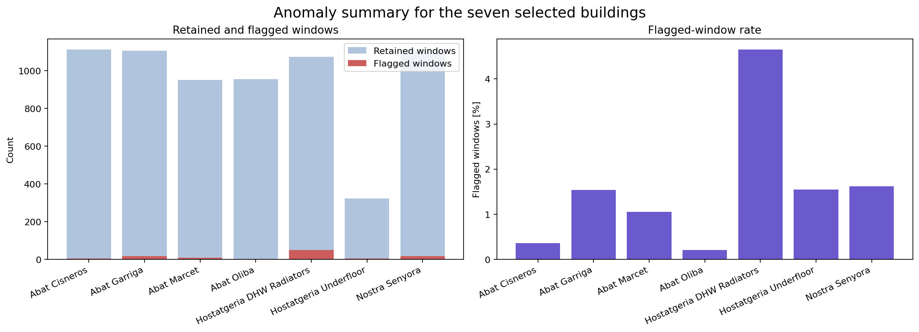
Figure 3. Retained-window count, flagged-window count, and flagged-window rate for the seven selected buildings.
Source: author-generated figure based on processed historical district-heating data.
Interpretation. This figure compares usable window count, flagged anomaly count, and flagged anomaly rate across the seven selected buildings. The retained-window count shows how much usable data each building contributes, the flagged-window count shows the absolute anomaly volume, and the flagged rate shows the relative density of anomalies after accounting for dataset size. The retained-window differences arise from unequal raw-data coverage, missing-data patterns, inactive-heating periods, and the fact that some windows fail the active-share or completeness thresholds during preprocessing.
Figure 3A summarizes the median daily retained-window profiles for all seven buildings.
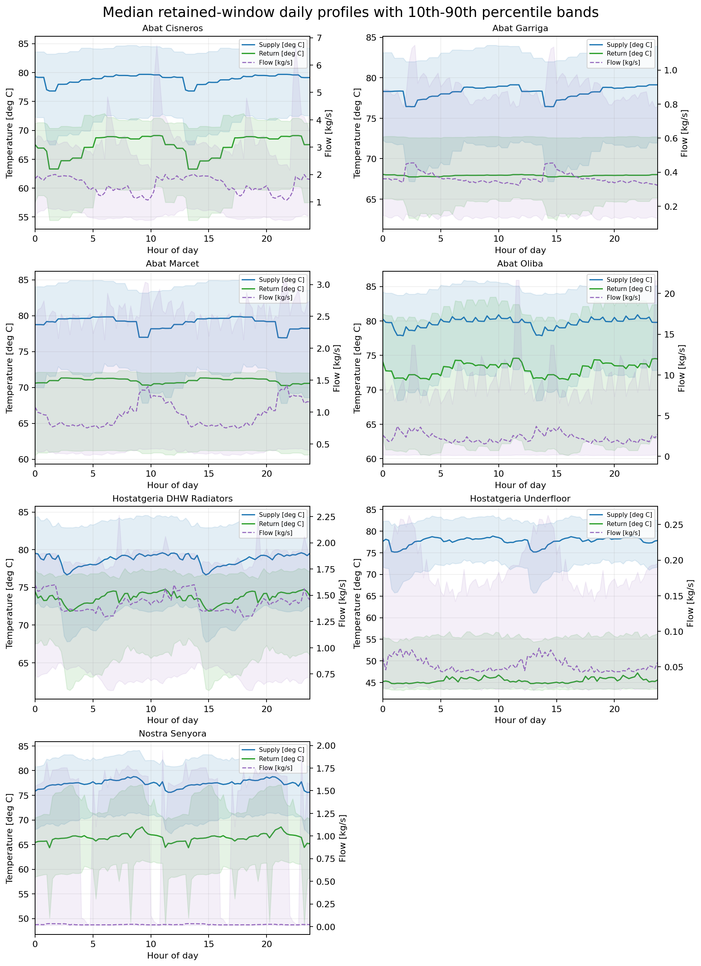
Figure 3A. Median daily retained-window profiles for the seven selected buildings. Supply and return temperatures are shown with 10th-90th percentile bands, and flow is shown on the secondary axis with its own 10th-90th percentile band.
Source: author-generated figure based on all retained 24-hour windows before anomaly filtering.
Interpretation. This figure summarizes how the seven buildings typically behave across the day before focusing on anomalies. It is useful for understanding building-to-building differences in thermal level, return behaviour, and flow magnitude, and therefore helps explain why the retained-window counts and anomaly rates are not identical across sheets.
Figure 4 shows the reconstruction-error timelines that underpin the anomaly counts reported in this section.
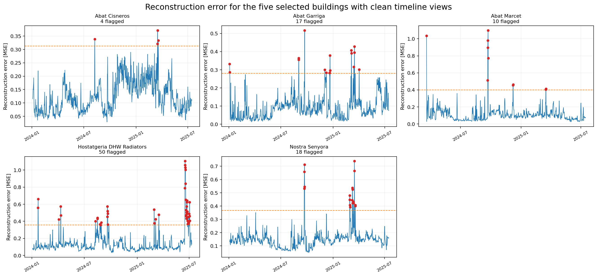
Figure 4. Reconstruction-error timelines for the five selected buildings with clean timeline views. The dashed line is the anomaly threshold and the highlighted points are flagged windows.
Source: author-generated figure based on autoencoder reconstruction error across retained windows.
Interpretation. Each panel plots reconstruction error over chronological window start time for one building. The dashed line is the anomaly threshold learned from the training-error distribution, and the highlighted points are windows whose reconstruction error exceeds that threshold. This comparison is intentionally restricted to the five buildings whose retained-window timelines are not dominated by long faulty constant-value periods. Abat Oliba and Hostatgeria Underfloor remain part of the thesis result set, but they are interpreted mainly through their anomaly windows and summary statistics rather than through this timeline comparison.
Figure 5 shows the top reviewed anomaly window for Abat Cisneros.
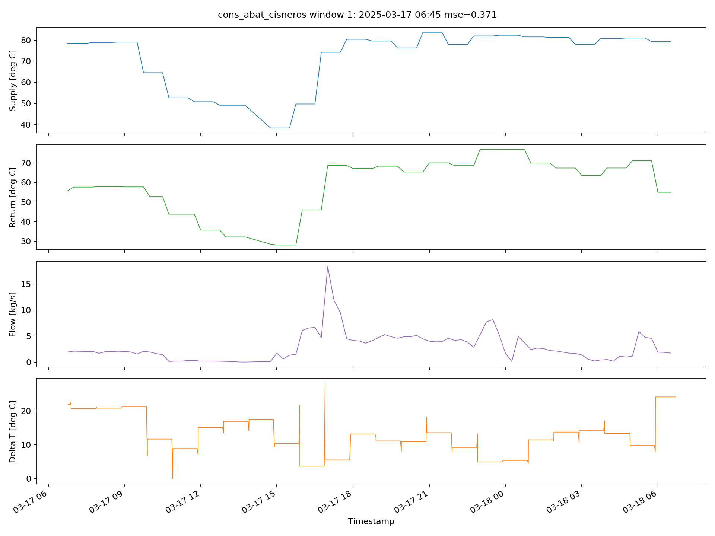
Figure 5. Abat Cisneros top reviewed anomaly window. The four traces show supply temperature [deg C], return temperature [deg C], flow [kg/s], and delta-T [deg C] over the 24-hour anomaly window.
Source: author-generated anomaly inspection plot for Abat Cisneros.
Interpretation. This anomaly is flow-dominant. The figure should be read from top to bottom. The first two panels show whether supply and return remain smooth or shift abruptly. The third panel shows the physically scaled flow behaviour in kg/s, which is the main panel of interest here. The fourth panel shows delta-T and highlights any overlap with the engineering low delta-T rule. Together the four traces indicate whether the abnormality is mainly hydraulic, mainly thermal, or coupled.
Figure 6 shows the top reviewed anomaly window for Abat Garriga.
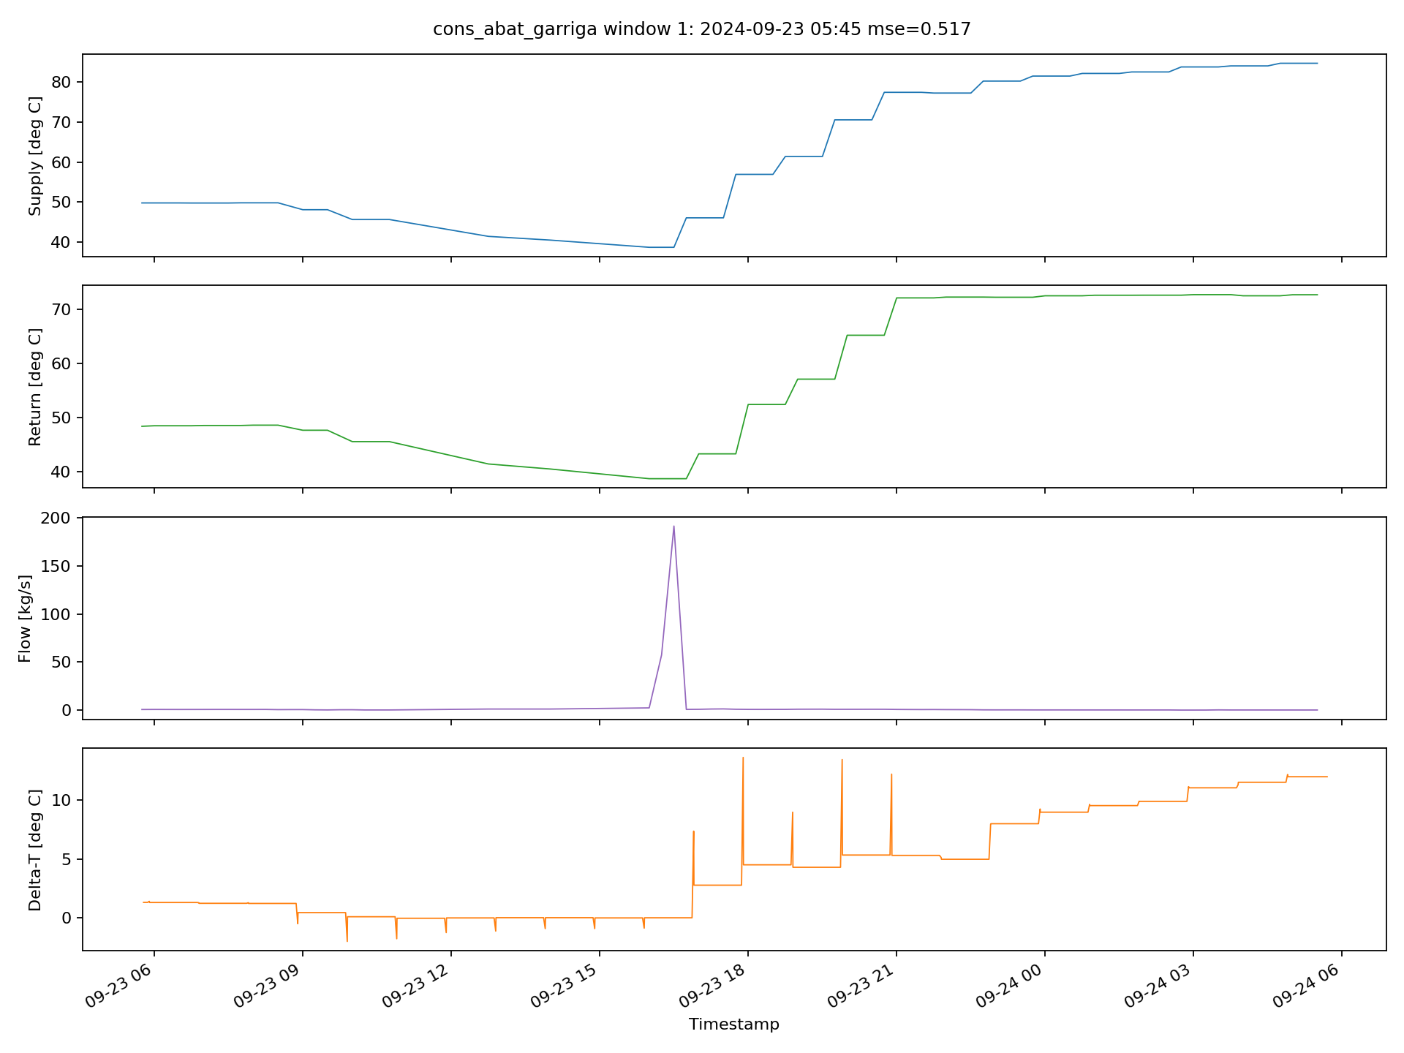
Figure 6. Abat Garriga top reviewed anomaly window. The four traces show supply temperature [deg C], return temperature [deg C], flow [kg/s], and delta-T [deg C] over the 24-hour anomaly window.
Source: author-generated anomaly inspection plot for Abat Garriga.
Interpretation. This anomaly is return-dominant. The main reading task is to compare the return-temperature trace against the supply trace and then check whether the flow profile changes in a way that supports a thermal explanation. The delta-T panel shows whether the abnormality also coincides with weak temperature separation.
Figure 7 shows the top reviewed anomaly window for Abat Marcet.
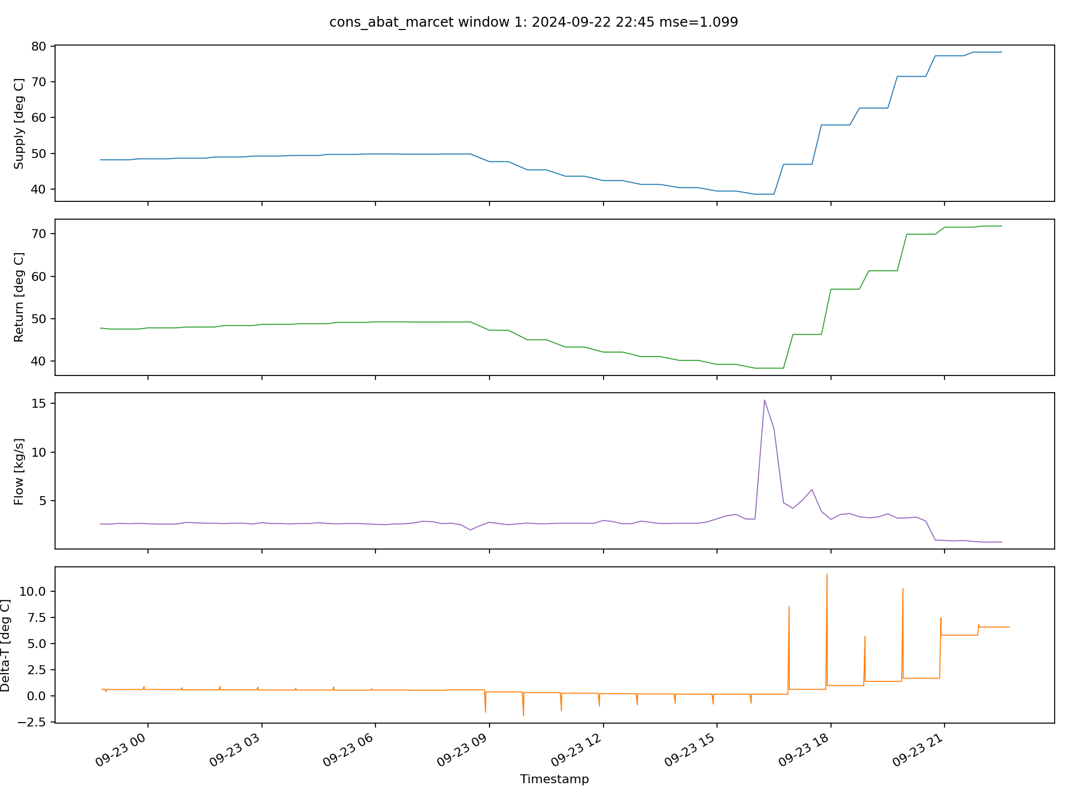
Figure 7. Abat Marcet top reviewed anomaly window. The four traces show supply temperature [deg C], return temperature [deg C], flow [kg/s], and delta-T [deg C] over the 24-hour anomaly window.
Source: author-generated anomaly inspection plot for Abat Marcet.
Interpretation. This anomaly is flow-dominant. The figure is useful for checking whether the main abnormality appears as unusual flow behaviour, weak thermal separation, or a coordinated change across all channels. Because the signals are synchronized, the reader can compare the timing of the abnormal flow behaviour with the temperature response.
Figure 8 shows the top reviewed anomaly window for Abat Oliba.
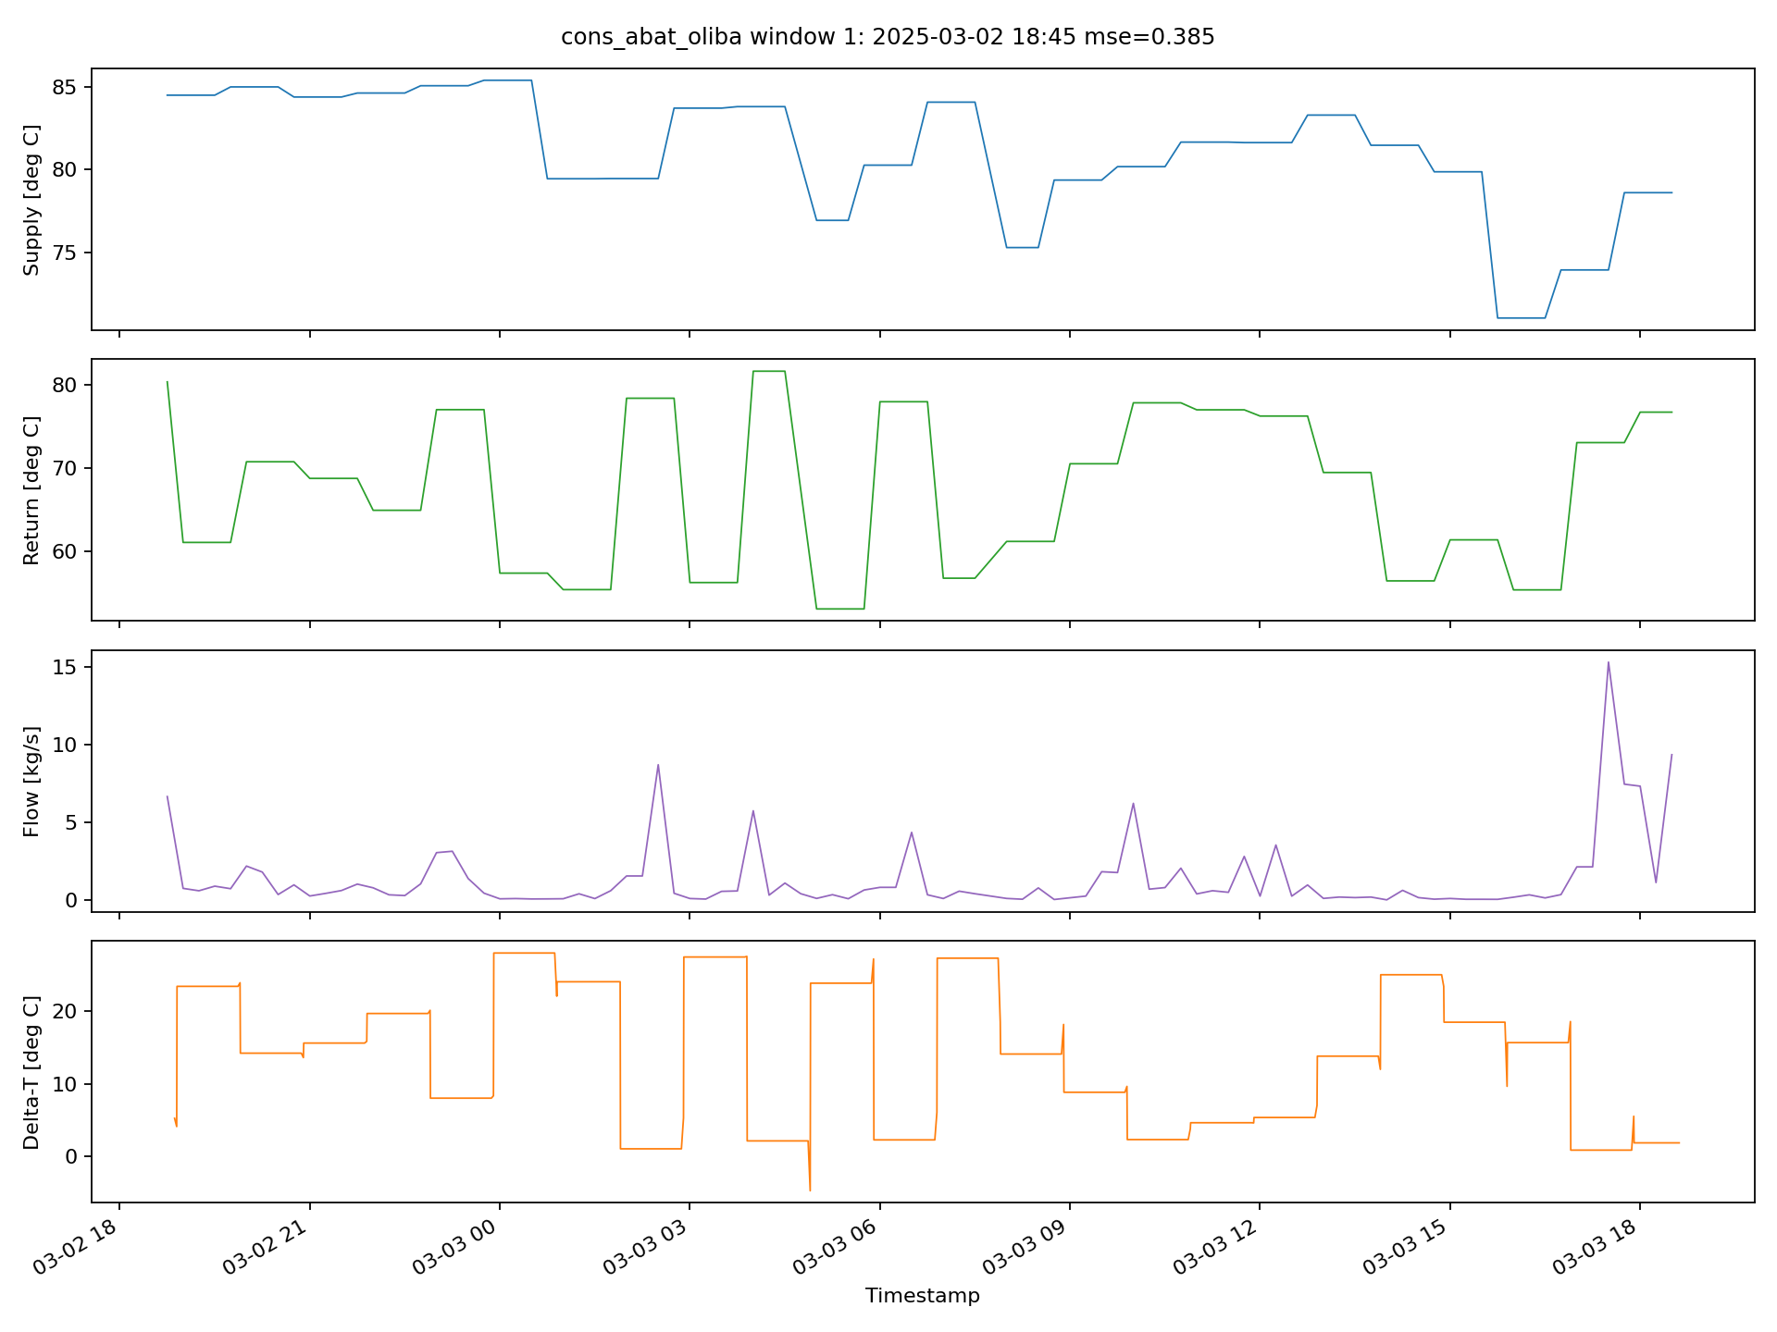
Figure 8. Abat Oliba top reviewed anomaly window. The four traces show supply temperature [deg C], return temperature [deg C], flow [kg/s], and delta-T [deg C] over the 24-hour anomaly window.
Source: author-generated anomaly inspection plot for Abat Oliba.
Interpretation. This anomaly is return-dominant. The figure should be interpreted by comparing the return-temperature behaviour with the supply trace and then checking whether the flow panel remains plausible in physical scale. This is particularly important for Abat Oliba because the sheet was central in earlier flow-sensitivity analysis.
Figure 9 shows the top reviewed anomaly window for Hostatgeria DHW Radiators.
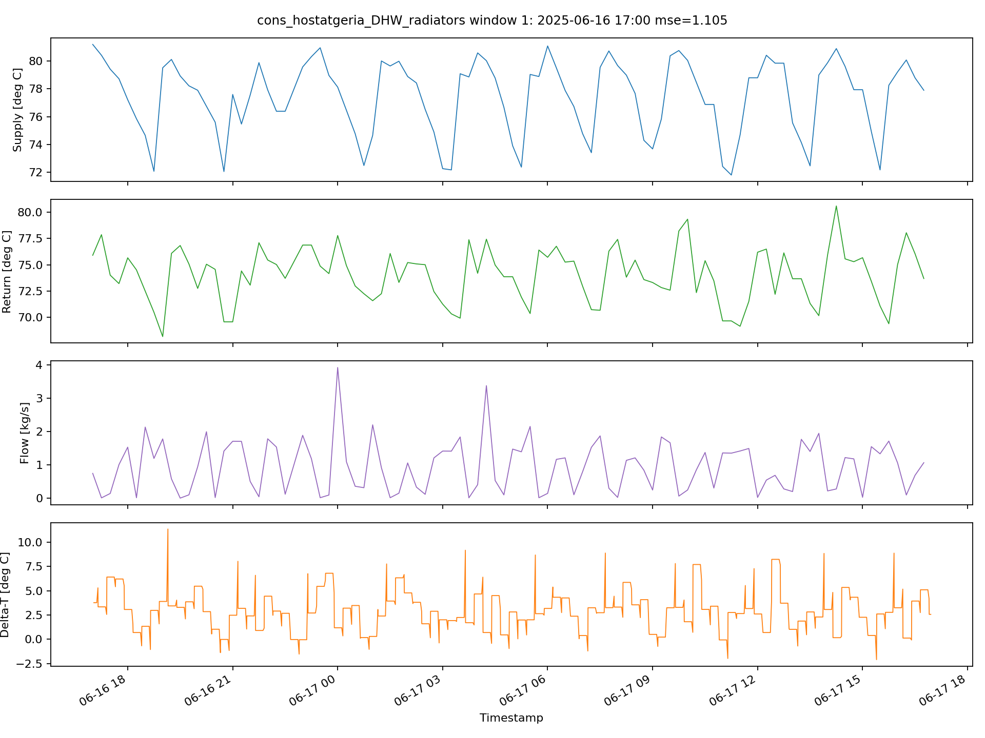
Figure 9. Hostatgeria DHW Radiators top reviewed anomaly window. The four traces show supply temperature [deg C], return temperature [deg C], flow [kg/s], and delta-T [deg C] over the 24-hour anomaly window.
Source: author-generated anomaly inspection plot for Hostatgeria DHW Radiators.
Interpretation. This anomaly is flow-dominant. The figure is useful for checking whether the detector is responding to a recurring hydraulic pattern rather than to a one-off temperature excursion. The relative stability of the temperature panels compared with the flow panel helps explain why this sheet tends to accumulate many flow-dominant anomalies.
Figure 10 shows the top reviewed anomaly window for Hostatgeria Underfloor.
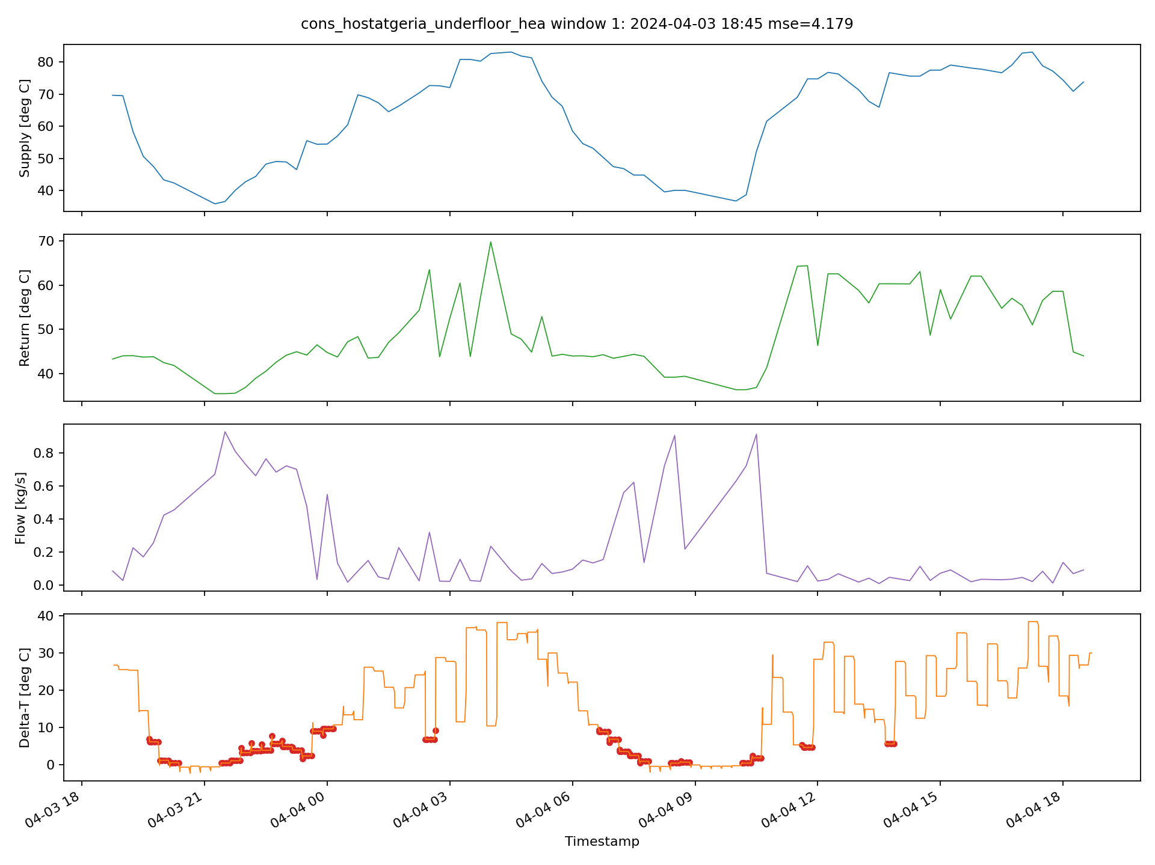
Figure 10. Hostatgeria Underfloor top reviewed anomaly window. The four traces show supply temperature [deg C], return temperature [deg C], flow [kg/s], and delta-T [deg C] over the 24-hour anomaly window.
Source: author-generated anomaly inspection plot for Hostatgeria Underfloor.
Interpretation. This anomaly is supply-dominant and remains the strongest thesis case. The supply panel carries the main abnormality, the return and flow panels provide context, and the delta-T panel shows that the same window also overlaps the engineering baseline. This makes it the clearest example where the learned detector and the engineering reference point to the same abnormal operating period.
Figure 11 shows the top reviewed anomaly window for Nostra Senyora.
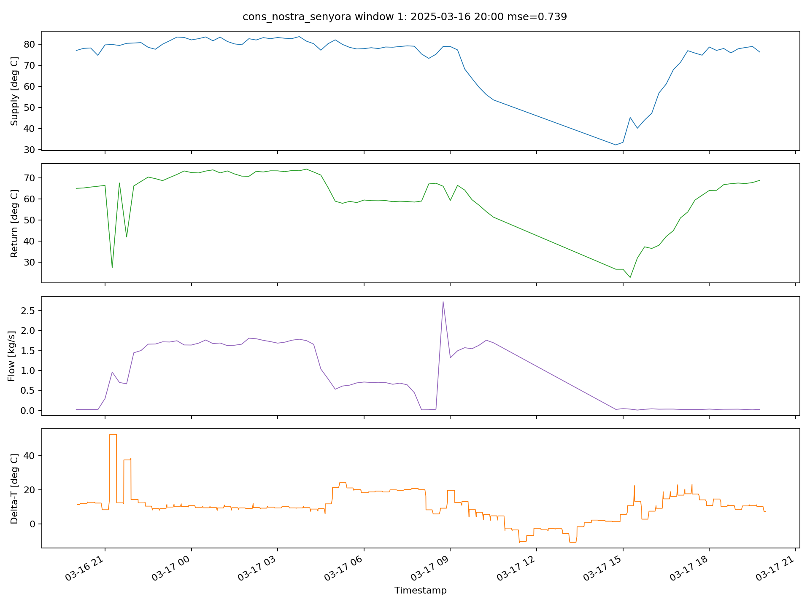
Figure 11. Nostra Senyora top reviewed anomaly window. The four traces show supply temperature [deg C], return temperature [deg C], flow [kg/s], and delta-T [deg C] over the 24-hour anomaly window.
Source: author-generated anomaly inspection plot for Nostra Senyora.
Interpretation. This sheet mixes supply-dominant and return-dominant behaviour in the broader result summary, so the top reviewed anomaly should be read by checking whether the strongest deviation is thermal on the supply side, thermal on the return side, or accompanied by a change in flow timing.
Figure 11A compares observed and reconstructed signals for the top Garriga anomaly window.
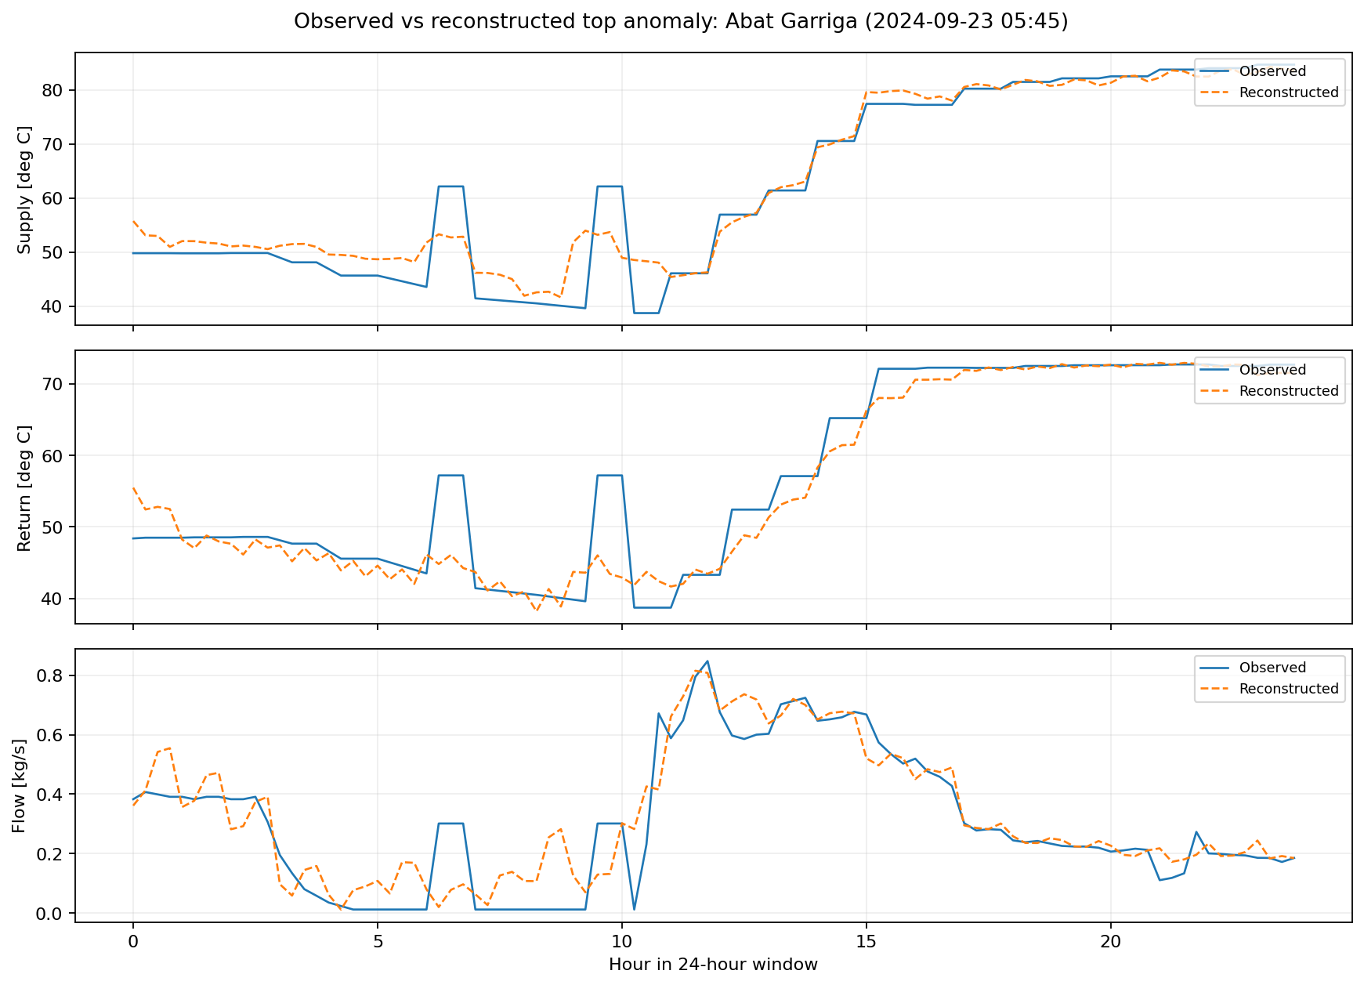
Figure 11A. Observed versus reconstructed signals for the top Abat Garriga anomaly window.
Source: author-generated figure from the trained joint autoencoder and the highest-scoring Garriga anomaly window.
Interpretation. This figure explains why the Garriga example is classified as return-dominant even though the flow trace looks visually active. Dominance is assigned by reconstruction error, not by raw amplitude. The model reproduces the flow channel comparatively well, while the return channel shows the largest mismatch between observed and reconstructed behaviour.
Figure 11B compares observed and reconstructed signals for the strongest Underfloor anomaly window.
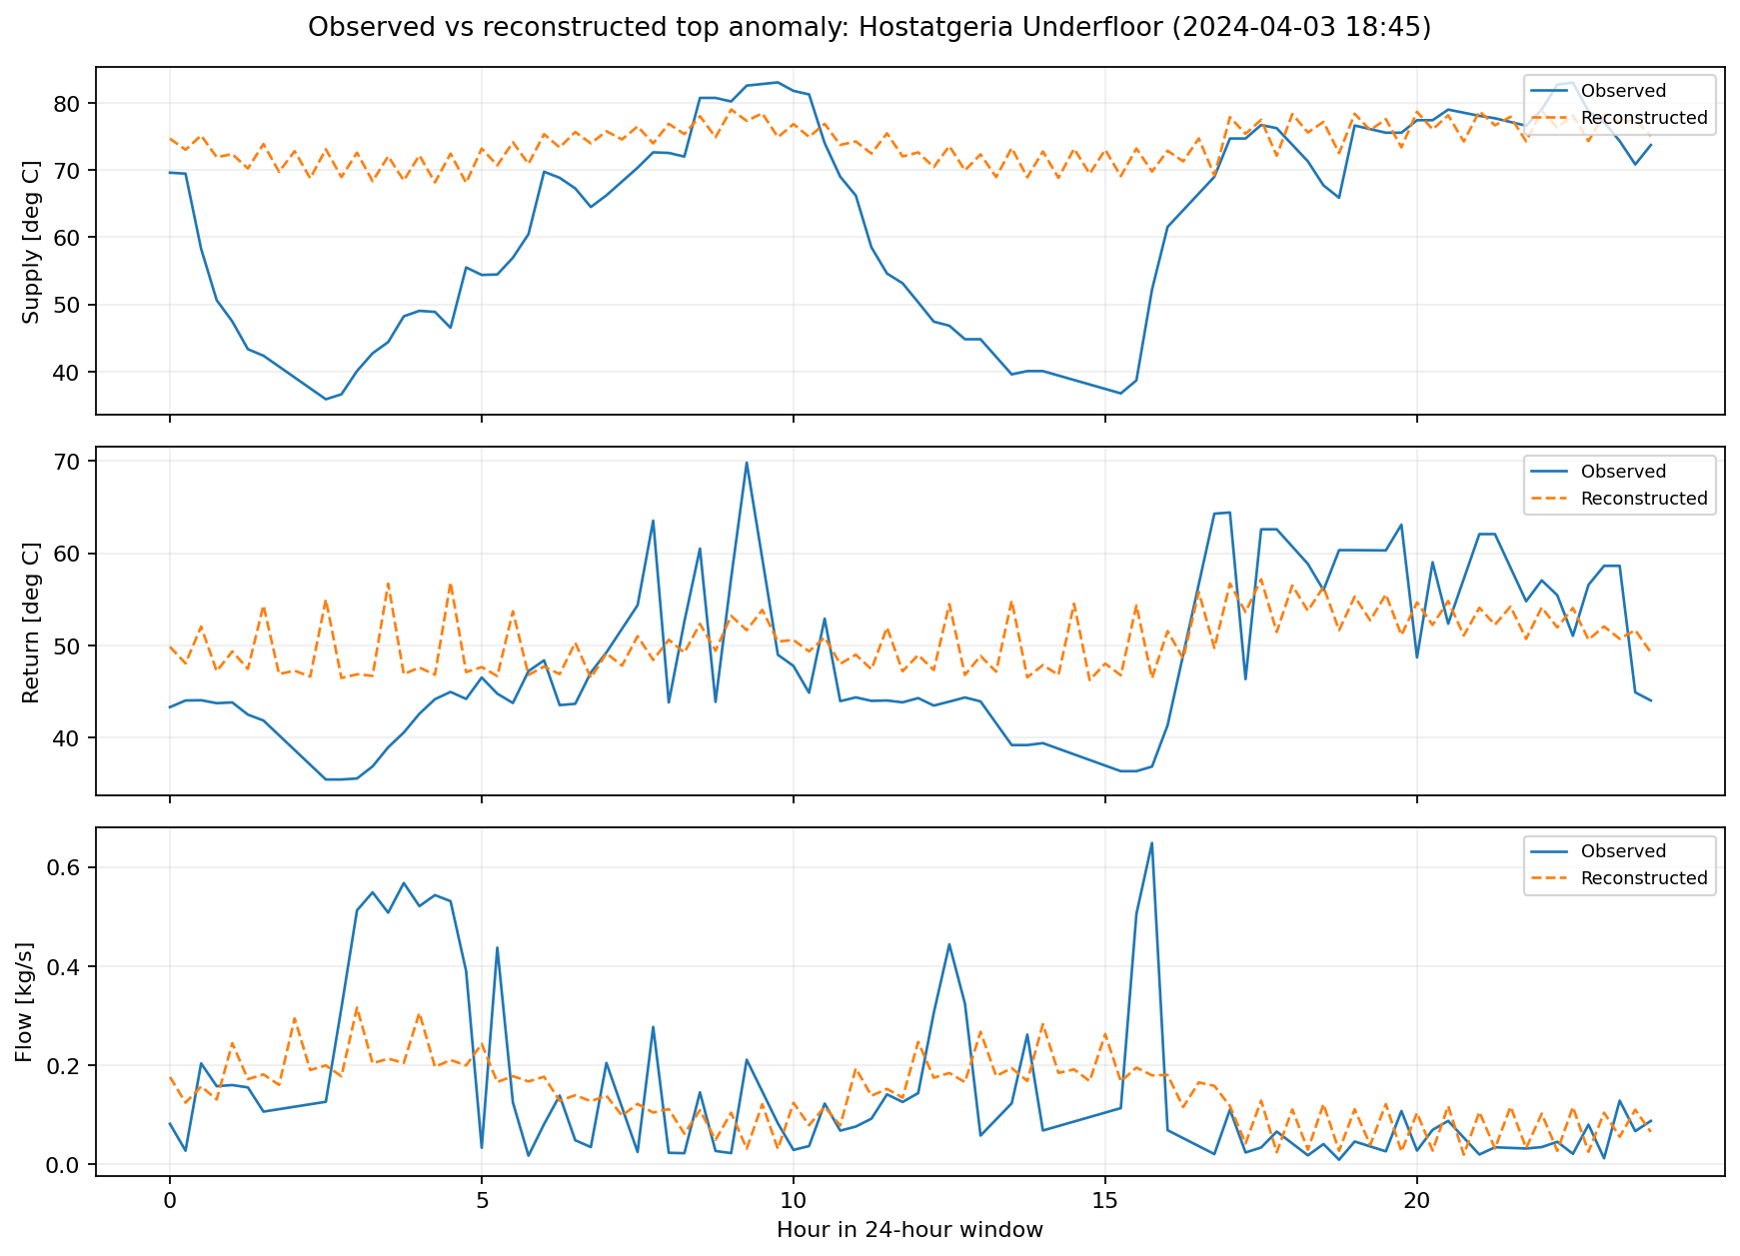
Figure 11B. Observed versus reconstructed signals for the top Hostatgeria Underfloor anomaly window.
Source: author-generated figure from the trained joint autoencoder and the highest-scoring Underfloor anomaly window.
Interpretation. This figure shows the model failing much more strongly on the supply channel than on the other channels, which is why the Underfloor case remains the clearest supply-dominant thesis example. It also makes the reconstruction-based anomaly logic more concrete than the raw signal plot alone.
Figure 11C compares the joint Underfloor autoencoder with univariate alternatives trained on individual channels.
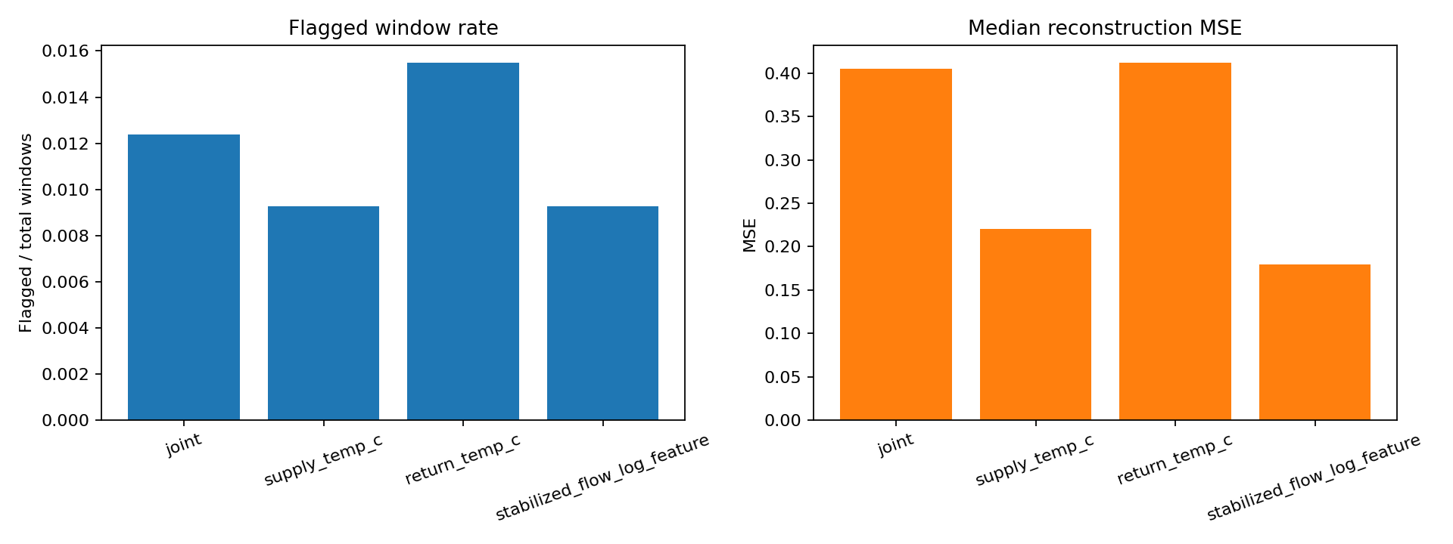
Figure 11C. Joint-versus-univariate comparison for Hostatgeria Underfloor, using flagged-window rate and median reconstruction MSE.
Source: author-generated comparison between the joint three-channel autoencoder and single-channel autoencoders for the Underfloor sheet.
Interpretation. This figure shows that the single-channel alternatives do not behave identically. Return-only reconstruction yields the highest flagged-window rate, while the flow-only model gives the lowest median reconstruction error. The joint model remains between those extremes and is kept as the main thesis detector because it preserves cross-channel context instead of forcing the anomaly decision to come from only one signal at a time.

4.2 Dominant-feature interpretation
The clearest current anomaly-typing view is the dominant-feature analysis. Across the seven-building set, the anomalies are mainly flow-dominant and return-dominant, with Hostatgeria Underfloor providing the clearest supply-dominant case. This indicates that the autoencoder is detecting multiple anomaly families rather than only one repeated signature.
The seven-building result set is useful precisely because it shows several different anomaly regimes at once. Flow-dominant behaviour appears most clearly in Abat Cisneros, Abat Marcet, and especially Hostatgeria DHW Radiators. Return-dominant behaviour is most visible in Abat Garriga and part of Abat Oliba. Supply-dominant behaviour is rarer but stronger where it occurs, with Hostatgeria Underfloor remaining the clearest case and Nostra Senyora contributing additional supply-heavy windows. This diversity is one of the strongest arguments that the detector is not simply reacting to one generic artifact.
Figure 12 shows which feature dominates the anomaly score for each building.
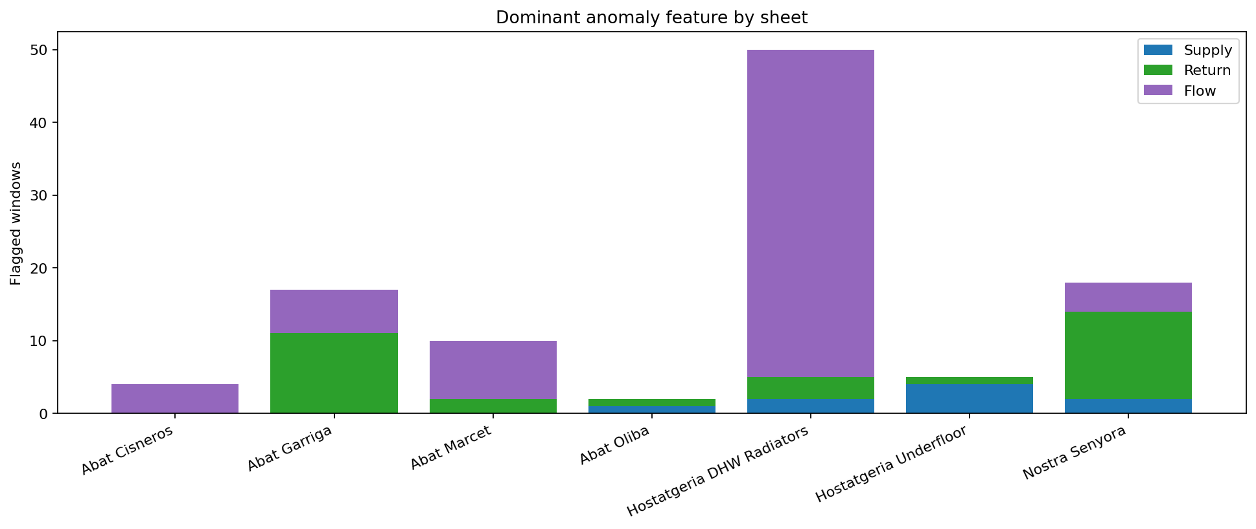
Figure 12. Dominant anomaly feature by sheet for the seven selected buildings.
Table 2. Dominant-feature counts among flagged anomaly windows.
Building | Supply | Return | Flow | Flagged
Abat Cisneros | 0 | 0 | 4 | 4
Abat Garriga | 0 | 11 | 6 | 17
Abat Marcet | 0 | 2 | 8 | 10
Abat Oliba | 1 | 1 | 0 | 2
Hostatgeria DHW Radiators | 2 | 3 | 45 | 50
Hostatgeria Underfloor | 4 | 1 | 0 | 5
Nostra Senyora | 2 | 12 | 4 | 18
Interpretation. This table gives the exact counts behind the dominant-feature figure. It is useful when a stacked bar is visually clear but the supervisor needs the numerical split between supply-, return-, and flow-dominant anomaly windows.
Source: author-generated figure using per-feature reconstruction errors.
Interpretation. This figure groups detected anomalies by the feature with the largest reconstruction-error contribution. It should be read as a feature-type summary across buildings: supply, return, and flow remain present in all analyses, but one channel contributes the largest share of the anomaly score more often in some buildings than in others.
Figure 13 visualizes anomalies in the actual per-feature reconstruction-error space.
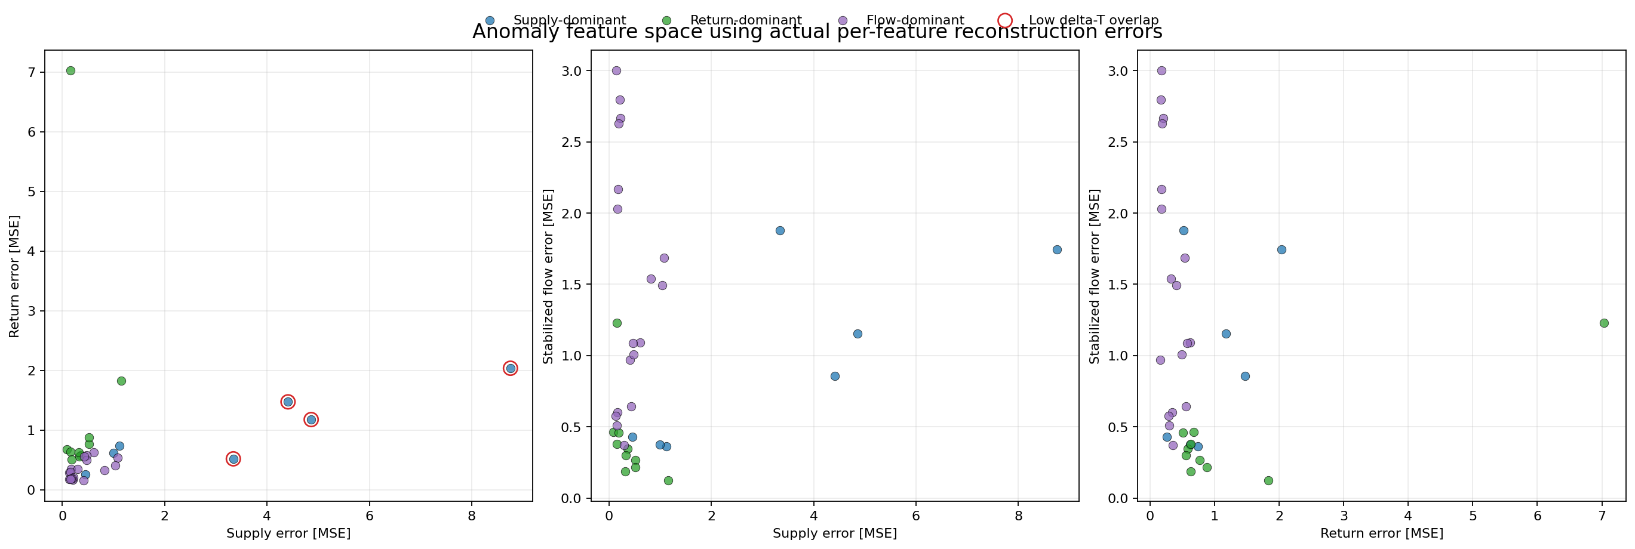
Figure 13. Anomaly feature space using actual per-feature reconstruction errors, with point color indicating the dominant anomaly feature.
Source: author-generated figure based on anomaly windows and per-feature error attribution.
Interpretation. Each point is one anomaly window, positioned using the actual per-feature reconstruction errors rather than a projected embedding. The axes therefore correspond to real model-error quantities, and the point color identifies the dominant anomalous feature for that window.

4.3 Low delta-T overlap
Only one sheet, cons_hostatgeria_underfloor_hea, shows strong overlap between top reviewed autoencoder anomalies and the low delta-T baseline. This should be interpreted carefully. It makes underfloor heating the strongest validated case, but the absence of overlap in the other six buildings does not invalidate the autoencoder. It instead suggests that many detected anomalies are not low delta-T events and therefore require interpretation through dominant feature, flow-channel behavior, and domain review.
Figure 14 compares the number of autoencoder anomalies with the engineering low delta-T baseline.
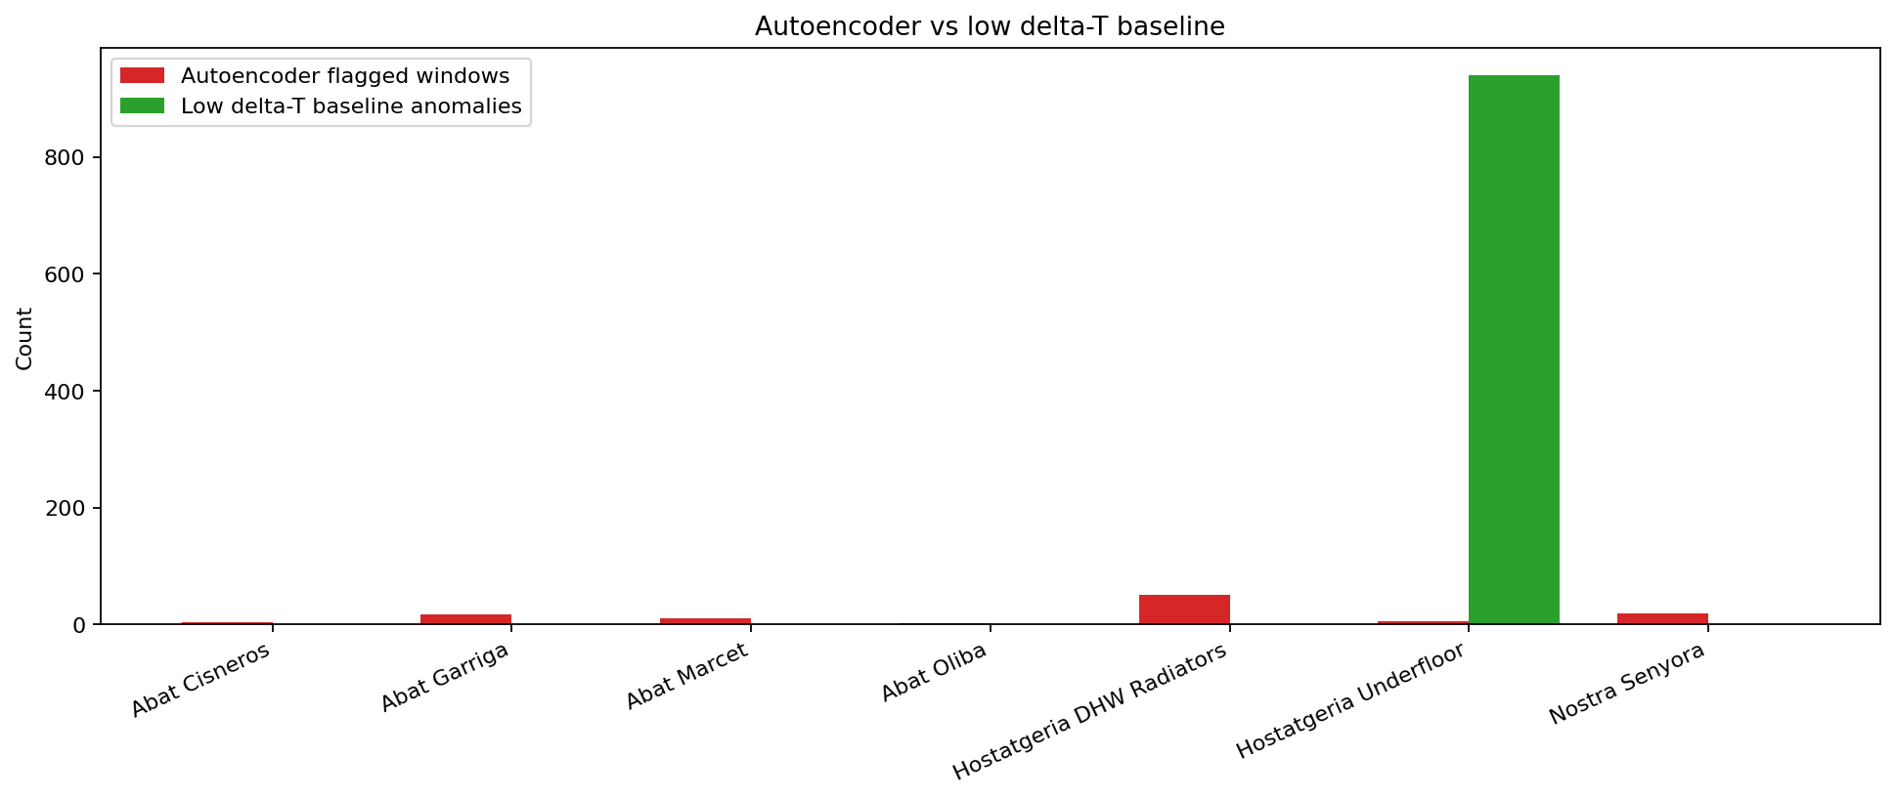
Figure 14. Autoencoder anomaly counts compared with the engineering low delta-T baseline for the seven selected buildings.
Source: author-generated figure using autoencoder anomaly counts and baseline overlap checks.
Interpretation. This figure compares the number of windows flagged by the learned detector with the number associated with the low delta-T engineering reference. Similar counts suggest partial agreement, while differences indicate that the autoencoder is also finding anomaly types outside the narrow low delta-T rule.
Figure 15 shows the extent to which reviewed anomaly windows overlap low delta-T events.
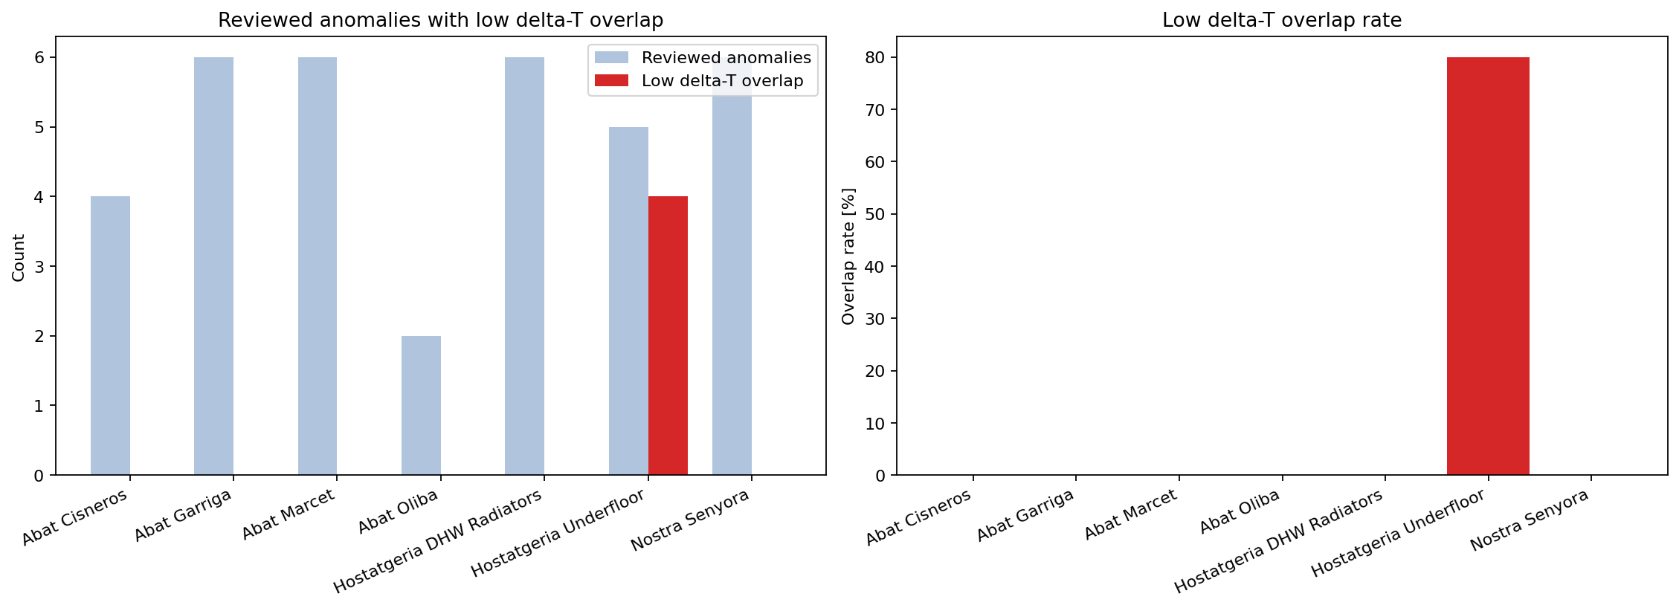
Figure 15. Reviewed anomaly windows with low delta-T overlap and the corresponding overlap rate.
Source: author-generated figure based on reviewed anomaly windows and baseline overlap matching.
Interpretation. The overlap count shows how many reviewed anomalies coincide with low delta-T events, and the overlap rate normalizes this by the number of reviewed anomalies. High overlap supports a familiar engineering reading, while low overlap suggests that the detected anomalies belong to other behavioural categories.
The low delta-T comparison should also be interpreted asymmetrically rather than as a pass-fail test. Overlap with the baseline is useful when it occurs, because it links the learned anomaly score to a familiar engineering symptom. Lack of overlap, however, does not automatically weaken the detector. It may simply indicate that the flagged window belongs to another anomaly family, for example an unusual return-temperature pattern or unstable flow behaviour that does not appear as an extreme low delta-T event. This is why the baseline is a reference point rather than a ground-truth oracle in the thesis.

4.4 Operating regimes
Operating-regime clustering indicates that daily windows do not form one undifferentiated population. Some sheets occupy very distinctive regimes, and regime occupancy is uneven. Underfloor heating stands out as the most distinctive operating-regime case. This supports the conclusion that its anomalies are associated with a coherent subsystem behavior rather than random variation.
Figure 16 summarizes the operating-regime cluster occupancy for the seven selected buildings.
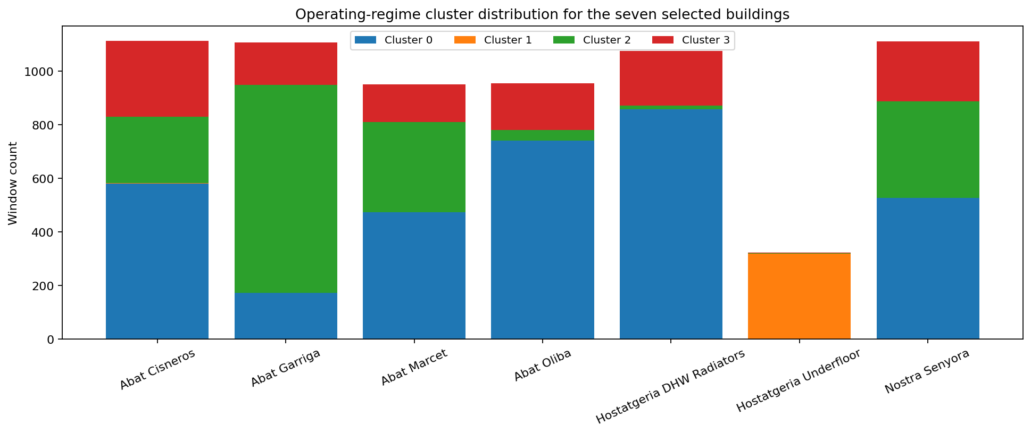
Figure 16. Operating-regime cluster distribution for the seven selected buildings.
Table 3. Operating-regime cluster anomaly rates.
Building | Cluster | Windows | Anomaly windows | Rate [%]
Abat Cisneros | 3 | 284 | 4 | 1.41
Abat Garriga | 0 | 173 | 6 | 3.47
Abat Garriga | 2 | 776 | 2 | 0.26
Abat Garriga | 3 | 158 | 9 | 5.70
Abat Marcet | 3 | 141 | 10 | 7.09
Abat Oliba | 0 | 740 | 1 | 0.14
Abat Oliba | 3 | 174 | 1 | 0.57
Hostatgeria DHW Radiators | 0 | 858 | 37 | 4.31
Hostatgeria DHW Radiators | 3 | 203 | 13 | 6.40
Hostatgeria Underfloor | 1 | 318 | 2 | 0.63
Hostatgeria Underfloor | 3 | 3 | 3 | 100.00
Nostra Senyora | 0 | 527 | 3 | 0.57
Nostra Senyora | 2 | 359 | 1 | 0.28
Nostra Senyora | 3 | 225 | 14 | 6.22
Interpretation. This table adds the anomaly rate inside each occupied operating-regime cluster. It helps show whether anomalies are spread evenly across regimes or concentrated in specific daily-pattern clusters.
Source: author-generated figure based on operating-regime clustering across retained windows.
Interpretation. The cluster labels are data-driven groups of similar daily behaviour rather than named physical modes. What matters is whether a building occupies many regimes or concentrates in a few, because that helps explain why anomaly behaviour is not uniform across the selected sheets.
The operating-regime view is most informative when it is used comparatively. A building whose retained windows concentrate heavily in one or two clusters is behaving more repetitively at the daily-pattern level than a building whose windows spread across many clusters. That does not by itself define anomaly severity, but it helps explain why some sheets produce sharper anomaly families while others produce a broader mix of flagged behaviour.

4.5 Threshold comparison
As already shown in Figure 2, the comparison between p99 and 3-sigma shows that threshold choice materially affects anomaly counts. The effect is sheet-dependent rather than global: some sheets become more selective under 3-sigma, while others become less selective. This is a useful result in itself because it shows that the training-error distribution shape must be considered when choosing an anomaly threshold.
Figure 16A visualizes the training-error distributions behind the 3-sigma thresholds across sheets.

Figure 16A. Training reconstruction-error distribution by sheet with threshold markers.
Table 4. Threshold comparison between p99 and 3-sigma.
Building | p99 T | 3-sigma T | p99 flags | 3-sigma flags | Delta
Abat Cisneros | 0.274 | 0.312 | 9 | 4 | -5
Abat Garriga | 0.318 | 0.280 | 9 | 17 | +8
Abat Marcet | 0.430 | 0.400 | 8 | 10 | +2
Abat Oliba | 0.308 | 0.342 | 12 | 2 | -10
Hostatgeria DHW Radiators | 0.460 | 0.356 | 29 | 50 | +21
Hostatgeria Underfloor | 2.056 | 1.539 | 4 | 5 | +1
Nostra Senyora | 0.452 | 0.366 | 9 | 18 | +9
Interpretation. This table shows that the 3-sigma rule is not uniformly stricter than p99. The change in flagged windows depends on the shape and spread of each building's training-error distribution.
Source: author-generated figure based on training-window reconstruction errors under the 3-sigma evaluation pack.
Interpretation. This figure is the sheet-level detail view behind Figure 2 rather than a duplicate of it. Figure 2 introduces the thresholding idea at method level, while Figure 16A shows the actual training-error distributions building by building. It helps explain why the same threshold rule does not behave uniformly across buildings: some sheets have compact error bands, while others have wider or more skewed tails.

4.6 Train-test split and anomaly timing
The anomalies are not confined to the first chronological portion of the data. Some buildings show both training and later test-period anomalies, which is useful when thinking about eventual live deployment and about whether the detector can remain informative on later unseen periods.
Figure 17 shows how anomalies are distributed between the training period and the later chronological period.
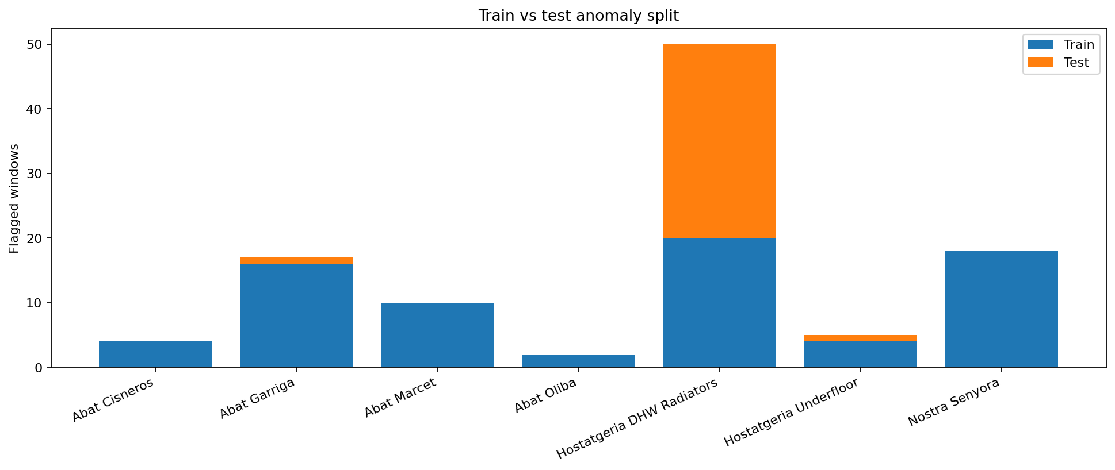
Figure 17. Train-versus-test anomaly split for the seven selected buildings.
Source: author-generated figure using the chronological train-test partition of the retained windows.
Interpretation. This figure separates flagged anomalies by whether they occur in the earlier chronological portion or in the later period. It is useful for judging whether anomalies persist beyond the first historical segment and therefore remain relevant for later operational monitoring.

5 Discussion

5.1 What is currently convincing
The most convincing result of the thesis is that reconstruction-based anomaly detection is viable in this small district-heating setting even without reliable fault labels. The method does not produce a uniform anomaly pattern across all buildings; instead, it identifies a set of building-specific abnormal windows that can be discussed in terms of supply temperature, return temperature, and the flow-related input channel. This is an important result because it shows that the detector is not merely reacting to noise. The clearest thesis case remains Hostatgeria Underfloor, where the anomalies are physically distinctive, remain interpretable under alternative flow-channel formulations, and show overlap with the engineering low delta-T baseline.
A second convincing point is that the method remains meaningful even when the engineering baseline does not overlap strongly with every detected anomaly. If the autoencoder only reproduced low delta-T events, then its contribution over a simple rule-based screen would be limited. The present results suggest a more interesting picture: some anomalies align with the baseline, while others appear to reflect different forms of unusual thermal or hydraulic behaviour that still deserve review.
One further reason the Underfloor case matters is methodological rather than only visual. It is the clearest example where several interpretation layers point in the same direction: a strong reconstruction anomaly, a stable dominant-feature assignment, a visibly abnormal signal window, and overlap with the low delta-T engineering reference. This makes it the strongest partial validation case in the thesis, even though it still does not replace formal labelled evaluation.

5.2 What remains uncertain
The biggest remaining limitation is validation. Most sheets do not have confirmed fault labels, so the status of a detected anomaly cannot usually be stated as a verified fault event. Instead, interpretation depends on triangulation across several complementary views:
- reconstruction error
- dominant feature
- signal plots
- low delta-T overlap
- supervisor and domain review
This has a direct implication for how the results should be presented. Most detected windows should be framed as credible anomaly candidates rather than confirmed faults. That is not a weakness in the thesis framing; it is an honest consequence of the available evidence. In a low-label industrial setting, the value of the method lies in prioritizing unusual and interpretable windows for expert review, not in claiming certainty that the underlying fault mechanism is already known.
This difference from benchmark-style research is important. In a labelled benchmark study, the main question is usually whether one detector achieves better accuracy, recall, or F-score than another under a fixed protocol. In this thesis, the central question is different: whether the detector can convert weakly structured historical data into a manageable set of reviewable windows, each supported by signal plots, per-feature error attribution, and comparison against simple engineering references. That is a narrower but still meaningful research contribution because it addresses the decision conditions under which many industrial monitoring projects actually begin.
A second uncertainty concerns transportability across buildings. The results show that anomaly frequency, dominant feature, and baseline overlap differ markedly across the seven substations. This implies that one should be cautious about interpreting a high anomaly count in one building as equivalent in meaning to the same count in another. Part of the thesis contribution is therefore comparative rather than universal: it demonstrates that building-level context remains necessary even when the same modeling pipeline is applied across all sheets.
This difference from benchmark-style research should be stated explicitly. In a labelled benchmark study, the main question is usually whether one detector achieves better accuracy, recall, or F-score than another under a fixed protocol. In this thesis, the central question is different: whether the detector can convert weakly structured historical data into a manageable set of reviewable windows, each supported by signal plots, per-feature error attribution, and comparison against simple engineering references. That is a narrower but still meaningful research contribution because it addresses the decision conditions under which many industrial monitoring projects actually begin.

5.3 Implications for live deployment
The historical result pack is already useful as preparation for live deployment. Once one to two months of live data become available, the intended strategy is to apply the historically trained detector prospectively and inspect the flagged windows through operational review. In practical terms, this means checking whether the anomaly windows correspond to meaningful events in building operation, control behaviour, maintenance records, or known abnormal conditions. The live-data phase will therefore function as an operational evaluation step rather than a conventional benchmark test.
The live-data period will also introduce practical constraints that are less visible in purely historical analysis. In a live setting, anomaly volume matters because too many alerts will reduce review quality, while too few alerts may miss relevant events. For that reason, the historical analysis of threshold choice, dominant-feature attribution, and building-specific behaviour is already valuable: it helps define what kind of anomaly output is likely to be actionable once the detector is run prospectively.
A final discussion point concerns what successful evaluation should look like after the thesis. In a fully labelled setting, one would expect event-level fault benchmarks, explicit alert reliability measures, and timing-based criteria such as earliness. Recent district-heating evaluation work shows the value of exactly those fault-centric metrics once service-validated labels become available [7]. The present thesis does not yet have that evidence base, which is why it focuses instead on interpretable anomaly ranking, cross-building comparison, and readiness for future live-data review.

5.4 Threats to validity
Several threats to validity remain. Internal validity is limited by the fact that anomaly status is inferred from reconstruction error rather than confirmed by a comprehensive event log. Construct validity is affected by the need to derive and model a flow-related channel from the available measurements, which means that some anomaly behavior may still reflect feature construction choices rather than only physical system faults. External validity is limited because the network is small and the seven sheets are heterogeneous, so the present findings should not be generalized automatically to larger or structurally different district-heating systems.
These threats do not invalidate the thesis, but they do define the scope of its claims. The work demonstrates that reconstruction-based anomaly detection is viable and interpretable in the available historical setting. It does not yet demonstrate benchmark-grade fault identification under fully validated labels. That stronger claim must be reserved for later live-data evaluation and future access to richer service or maintenance records.

6 Conclusion
This thesis develops and evaluates a reconstruction-based anomaly-detection pipeline for a small district-heating network with limited fault labels. The work takes the reference encoder-assisted clustering method as its main methodological reference, but adapts that reference to a setting where long historical coverage is more useful than large-scale peer-group clustering. The main result is that the proposed pipeline can identify anomalous daily operating windows that are not only statistically unusual, but also interpretable in terms of supply temperature, return temperature, and the flow-related input channel. The strongest case is Hostatgeria Underfloor, where the detected anomalies also align with a simple engineering low delta-T rule.
The broader building-level analysis shows that anomaly behaviour is heterogeneous across the network. Some buildings are mainly associated with flow-dominant anomalies, others are more return-dominant, and only a smaller number of cases are clearly supply-dominant. This supports the conclusion that the detector is capturing multiple anomaly families rather than one repeated signature. The flow-channel sensitivity analysis further shows that feature construction materially affects the interpretability of the detected anomalies, which justifies the final representation used in the main results. Operating-regime clustering remains useful as contextual support, but dominant-feature attribution is the clearer explanation layer for discussing anomaly type.
The transition to live-data evaluation is discussed further in Section 6.1.
From a thesis perspective, the contribution is therefore not the discovery of one universally validated fault class, but the construction of a defensible anomaly-detection and interpretation workflow for a realistic low-label district-heating dataset. That is an appropriate outcome for the available data setting and provides a solid basis for the transition from historical analysis to live operational use. A stronger post-thesis evaluation would require the kind of event-centered validation discussed in recent district-heating benchmark work, where accuracy, alert reliability, and earliness can be measured against service-validated fault records [7]. The present thesis does not yet have that evidence base, which is why its main contribution is methodological readiness and interpretable anomaly prioritization rather than benchmark-style fault-class performance.

6.1 Future work
The next stage of the work is to apply the current detector to live data and use that prospective period as an operational evaluation step. That stage will make it possible to compare flagged windows against ongoing system behaviour, operator observations, and any available maintenance or event context. A second priority is to refine threshold selection once live alert volume can be judged operationally rather than only historically. A third priority is to strengthen validation by collecting any maintenance, alarm, or manually reviewed event records that can be aligned with the flagged windows. Beyond deployment, a natural continuation of the thesis would be to broaden the building set as cleaner data become available and to compare the current joint autoencoder with alternative architectures or per-feature detectors under the same review workflow. Another extension is to incorporate contextual variables such as outdoor temperature, season, month, and day type. Their relevance follows from the broader system role of district heating in seasonal energy supply [19, 21]. The efficiency perspective in Heat Roadmap Europe points in the same direction [20]. Such context could reduce false positives by helping the detector separate genuinely abnormal behavior from expected seasonal regime shifts. If richer live measurements become available later, additional variables such as pressure, valve position, or occupancy-related proxies could also support more precise anomaly interpretation.

References
[1] HEAT: Hierarchical-constrained Encoder-Assisted Time series clustering for fault detection in district heating substations, Energy and AI, 2025.
[2] R. Chalapathy and S. Chawla, Deep Learning for Anomaly Detection: A Survey, arXiv:1901.03407, 2019.
[3] M. Jiang, C. Hou, A. Zheng, X. Hu, S. Han, H. Huang, X. He, P. S. Yu, and Y. Zhao, Weakly Supervised Anomaly Detection: A Survey, arXiv:2302.04549, 2023.
[4] G. E. Hinton and R. R. Salakhutdinov, Reducing the Dimensionality of Data with Neural Networks, Science, vol. 313, no. 5786, pp. 504-507, 2006.
[5] J. van Dreven, A. Cheddad, S. Alawadi, A. N. Ghazi, J. Al Koussa, and D. Vanhoudt, SHEDAD: SNN-Enhanced District Heating Anomaly Detection for Urban Substations, arXiv:2408.14499, 2024.
[6] E. Calikus, S. Nowaczyk, A. Sant'Anna, H. Gadd, and S. Werner, A data-driven approach for discovering heat load patterns in district heating, arXiv:1901.04863, 2019.
[7] C. M. A. Roelofs, E. Guevara Bastidas, T. Hugo, S. Faulstich, and A. Cadenbach, Enabling Predictive Maintenance in District Heating Substations: A Labelled Dataset and Fault Detection Evaluation Framework based on Service Data, arXiv:2511.14791, 2025.
[8] N. Mejri, L. Lopez-Fuentes, K. Roy, P. Chernakov, E. Ghorbel, and D. Aouada, Unsupervised Anomaly Detection in Time-series: An Extensive Evaluation and Analysis of State-of-the-art Methods, arXiv:2212.03637, 2022.
[9] T. Kieu, B. Yang, C. Guo, C. S. Jensen, Y. Zhao, F. Huang, and K. Zheng, Robust and Explainable Autoencoders for Unsupervised Time Series Outlier Detection, arXiv:2204.03341, 2022.
[10] V. Chandola, A. Banerjee, and V. Kumar, Anomaly Detection: A Survey, ACM Computing Surveys, vol. 41, no. 3, article 15, 2009.
[11] G. O. Campos, A. Zimek, J. Sander, R. J. G. B. Campello, and B. Micenkova, On the evaluation of unsupervised outlier detection: measures, datasets, and an empirical study, Data Mining and Knowledge Discovery, vol. 30, pp. 891-927, 2016.
[12] M. A. F. Pimentel, D. A. Clifton, L. Clifton, and L. Tarassenko, A review of novelty detection, Signal Processing, vol. 99, pp. 215-249, 2014.
[13] M. Markou and S. Singh, Novelty detection: a review - part 1: statistical approaches, Signal Processing, vol. 83, no. 12, pp. 2481-2497, 2003.
[14] P. Malhotra, L. Vig, G. Shroff, and P. Agarwal, LSTM-based Encoder-Decoder for Multi-sensor Anomaly Detection, Proceedings of the ICML 2016 Anomaly Detection Workshop, 2016.
[15] M. Sakurada and T. Yairi, Anomaly Detection using Autoencoders with Nonlinear Dimensionality Reduction, Proceedings of the MLSDA 2014 2nd Workshop on Machine Learning for Sensory Data Analysis, 2014.
[16] B. Zong, Q. Song, M. R. Min, W. Cheng, C. Lumezanu, D. Cho, and H. Chen, Deep Autoencoding Gaussian Mixture Model for Unsupervised Anomaly Detection, Proceedings of the 6th International Conference on Learning Representations Workshop Track, 2018.
[17] M. A. Belay, S. S. Blakseth, A. Rasheed, and P. S. Rossi, Unsupervised Anomaly Detection for IoT-Based Multivariate Time Series: Existing Solutions, Performance Analysis and Future Directions, Sensors, vol. 23, no. 3, 2023.
[18] All result figures in this thesis are author-generated from the historical district-heating dataset unless otherwise stated.
[19] H. Lund, S. Werner, R. Wiltshire, S. Svendsen, J. E. Thorsen, F. Hvelplund, and B. V. Mathiesen, 4th Generation District Heating (4GDH): Integrating smart thermal grids into future sustainable energy systems, Energy, vol. 68, pp. 1-11, 2014.
[20] D. Connolly, H. Lund, B. V. Mathiesen, S. Werner, B. Moller, U. Persson, T. Boermans, D. Trier, P. A. Ostergaard, and S. Nielsen, Heat Roadmap Europe: Combining district heating with heat savings to decarbonise the EU energy system, Energy Policy, vol. 65, pp. 475-489, 2014.
[21] H. Lund, P. A. Ostergaard, D. Connolly, and B. V. Mathiesen, The status of 4th generation district heating: Research and results, Energy, vol. 164, pp. 147-159, 2018.
[22] D. M. Hawkins, Identification of Outliers, London: Chapman and Hall, 1980.
[23] A. Zimek and P. Filzmoser, There and back again: Outlier detection between statistical reasoning and data mining algorithms, WIREs Data Mining and Knowledge Discovery, vol. 8, no. 6, e1280, 2018.

